Business Practice Manual for

Direct Telemetry

Version 21.0

Revised: May 21, 2026

Approval History
Approval Date :
Effective Date :
BPM Owner : Tricia Johnstone
BPM Owner’s Title : Director, Operational Readiness
Revision History
Version | PRR | Date | Description
21 | 1679 | 5/21/2026 | Added more clarity to the BatteryTelemetry data points, Instantaneous State Of Charge (SOC) and Maximum Continuous Energy limit  Added new Telemetry Data point, The Minimum Continuous Energy Limit
20 | 1599 | 2/21/2025 | Review and Revisions made. Removal of areas still referencing Dispersive. Clarification to definitions for VERMW and HSLMW points. Refinements to 6.1 Point Matrix; 12 PDRs. Updated sections 4.7.4, 5.5, 7.3.3, 8.4 (list of critical points and reporting requirements), 14.1, and 14.2. Updated CAISO website links
19 | 1390 | 10/7/2021 | Minor updates to Sections 6.2, 9.12, 11.2, 11.3, 11.4.1, 11.4.2, 11.5.1, 11.5.5 and 14.5
18 | 1380 | 8/10/2021 | Sections 6.1, 8.4.2 and 14.1 have been updated to include new Telemetry requirements.
17 | 1369 | 4/22/2021 | Section 14.1.3 has been updated to include the DCF requirement.
16 | 1327 | 2/19/2021 | Section 6.1 has been updated to include requirements for Psuedo ties of Shared Resources.
15 | 1318 | 1/11/2021 | Sections 6.1, 14.1 and 14.2 have been updated to include new Telemetry requirements.
14 | 1310 | 11/17/2020 | Section 4.7.4 has been updated to include the TLS communication requirements.  Section 6 and 14 are updated to include the new Telemetry data point for Hybrid resources.
13 | 1229 | 2/19/2020 | Removing Dispersive Technologies from Section 4, 5 and 9
12 | 1551 | 03/04/2019 | Section 4 has been accommodated to include an Internet Service Provider Communication option.  Section 8.4 Temporary Telemetry Exemption sections has been updated with new exemption requirements.
11 | 1054 | 05/02/2018 | Removed ECN requirement for resources 400MW or greater. Clarified maximum of 1200MW per connection aggregating up to 25 resources. Consolidated descriptions of real-time communications options into a single section (5.3). Moved prior section 14 (CAISO Security) into section 4.4 to consolidate all security topics under section 4 (Communications), including PKI and ECN agreements and Connected Entity Service Guides. Recharacterized RIG as any Real-Time Device that can meet CAISO functional, operational, and security objectives. Added Dispersive™ CISDN communications option. Added table of acronyms. Added table of exhibits, figures, and diagrams. Modified multiple diagrams. Non-Spinning Reserve Logic and Testing (previously section 11). Removed redundant Communication Technical Principles (previous section 13.4).
10 | 942 | 01/05/2017 | Minor edits to section 3.2.2.1, changes to Section 6.7 DNP3 Variation type, 7.1 Point Matrix. In section 10.7 and 10.12 email address is updated. New section 10.9 RIG data validation is added. 10.12 RIG Generation Acceptance test and 10.13 Final RIG Documentation sections has been removed. Changes to 17.2.2 UCON  definition. New section 17.5 Battery point definitions are added.
9 | 895 | 3/10/2016 | PRR 895 - Changes to Section 6.2.2 and 6.2.3 regarding PDR requirements. Change to Section 6.9 to update EIR RIG limit to 1200MW. Change to Section 12.4 to include SPIN Reserve Testing. Complete replacement of Section 14 to provide updated PDR Direct Telemetry Requirements.
8 | 832 | 5/29/2015 | PRR 832 – Changes to Section 6.2.2 to add language regarding PDR Timing Requirements.
7 | 821 | 3/26/2015 | PRR 821 - Added deadline for Wind/Solar site information form to paragraphs 13.4.2 and 13.5.4. Corrected reference to solar in paragraph 13.5.4. Removed Tables 13.4.2 and 13.5.4. Updated link for Network Connectivity Security Requirements and ECN Agreement in Section 10.6.
6 | 770 | 8/06/2014 | Added clarifying language and site information form links to section 13 Eligible Intermittent Resources (EIR), subsections 13.1 to 13.5 and combined sections 13.6 with 13.5. Added updated language to section 10. FNM Database Process and RIG Installation
5 | 726 | 4/03/2014 | Added language to section 6.10 exempting DRP’s from the RIG aggregation location limitation in the provision of real-time telemetry data for Proxy Demand Resources (PDR) (PRR 726)
4 | 719/725 | 3/21/2014 | Added clarifying language indicating that Reliability Demand Response Resources (RDRR) are not required to provide telemetry and therefore exempt from direct telemetry requirements to section 2.1 (PRR 725)
3 | 633 | 11/14/2012 | Removal of the Full Network Model time line guide and changes to EIR less than 10MW.
2 | 489 | 12/14/2011 | Added requirement for data quality flag propagation as new Section 6.8, added requirement for preliminary revenue metering package to Section 10.2, removed unnecessary definitions from Section 4, and made changes to ISP circuit exceptions in Section 5.3 per BPM PRR 489. Effective Date 12/01/11.
1 |  | 8/02/2011 | Initial BPM submittal document

TABLE OF CONTENTS
1. Introduction 24
1.1 Purpose of CAISO Business Practice Manuals 24
1.2 Purpose of This Business Practice Manual 24
1.3 Organization of This Business Practice Manual 24
1.4 References 25
2. CAISO Direct Telemetry 29
2.1 Direct Telemetry Process 29
2.2 Real-Time Device Defined 29
2.2.1 Remote Intelligence Gateway (RIG) Historically 30
2.2.2 Data Processing Gateway (DPG) Deprecated 30
2.2.3 RIG Re-characterized as Real-Time Device 30
2.3 Installation and Validation of Direct Telemetry 32
2.4 Flow of Real-Time Data 33
3. CAISO Responsibilities 35
3.1 Overview of CAISO Responsibilities 35
3.2 Exceptions to Direct Telemetry 35
3.3 Direct Telemetry Validation 36
3.3.1 Overview of Telemetry Installation Validation Process 36
3.3.2 CAISO Certification Responsibilities 39
3.3.3 Documentation Requirements 39
3.3.4 CAISO Review of Documentation 41
4. Communications 42
4.1 Overview of Communications Objectives 42
4.2 Choice of Connection Methods 42
4.3 Communication Context Diagram 43
4.4 Main Communication Options 46
4.5 Detailed Communication Options 46
4.6 Ruggedized Gateway Available 50
4.7 CAISO Security for Direct Telemetry 51
4.7.1 Data Confidentiality 51
4.7.2 Network Security Principles and Best Practices 51
4.7.3 Communication Security Characteristics 52
4.7.4 Communication Security Protocols 54
4.7.5 Communication and Network Documents 55
4.7.6 Connected Entity Service Guides 56
4.8 Reliability 57
4.8.1 Redundant Circuits 57
4.8.2 Data Validation 57
4.8.3 Voice Communications 57
4.8.4 Communications During Telemetry Failure 57
5. Operational Telemetry Requirements 58
5.1 Unit Telemetry Visibility 58
5.2 Performance Monitoring 58
5.2.1 Direct Telemetry Timing Requirements 58
5.2.2 PDR Timing Requirements 59
5.2.3 PDR Reading Requirements 60
5.3 CAISO Real-Time Communication Technical Design Options 60
5.3.1 Functional Components of Real-Time Communication Options 61
5.3.2 Transport Options 62
5.3.3 Transport Conceptual Diagrams 63
5.3.4 Direct Telemetry Hardware Options 67
5.4 CAISO EMS Interrogations 76
5.5 DNP3 Object and Variation Types for Real-Time Device Responses 76
5.6 Quality Flag Propagation to DNP3 78
5.7 Maximum MW Real-Time Device Limitation 79
5.8 Real-Time Device Location Requirements 80
5.9 Real-Time Device Market Resource Limitation 80
5.10 Cost Responsibility 80
6. Telemetry Data Points List 81
6.1 Point Matrix 81
6.2 Analog and Digital Notes 89
7. Availability and Maintenance 91
7.1 CAISO Reliability Requirements 91
7.2 CAISO-Controlled Grid Operation and Market Availability Requirement 91
7.3 Real-Time Device Operation and Maintenance 92
7.3.1 Coordination of Changes to the Real-Time Device 92
7.3.2 Database Configuration and Management Affecting the CAISO’s EMS 94
7.3.3 Routine Testing and Maintenance of Real-Time Devices 95
8. Real-Time Device Implementation 96
8.1 Engineering and Deployment 96
8.2 Real-Time Device Database Development 96
8.3 Telecommunication Circuit Installation and Power Requirements 96
8.4 Temporary Telemetry Exemptions 96
9. FNM Database Process and Real-Time Installation 104
9.1 CAISO FNM Database Process 104
9.2 New Database Submission 104
9.2.1 Standards to Submit Real-Time Device Database for CAISO Database Build 104
9.3 Real-Time Database Submittal Timeline 104
9.4 Network Physical Circuit Protection to the Resource 104
9.5 Network Circuit Provisioning and Monitoring 104
9.5.1 AT&T ECN or ANIRA IPsec VPN 104
9.5.2 Self-Maintained Network and Circuit Monitoring 105
9.6 Standards for Point-to-Point Testing with the CAISO 105
9.7 Required Personnel for Point testing 106
9.8 Real-Time Device Data Validation 107
9.9 Upgrade or Replacement of a Real-Time Device 107
9.10 Outage Management for Meter or Real-Time Device work 107
9.11 Digital Certificates 108
9.12 Wind and Solar FNM Documentation Required 110
10. AGC Operational Requirements for Generating Units 111
10.1 Required DNP3 and Telemetry Data Points for AGC 111
10.2 AGC Control (Bumpless Transfer) 111
11. Eligible Intermittent Resources (EIR) 113
11.1 Applicability 113
11.2 Power Reliability Requirements 113
11.3 Basic Meteorological Data 113
11.3.1 Meteorological Wind Speed 113
11.3.2 Meteorological Wind Direction 113
11.3.3 Meteorological Barometric Pressure 113
11.3.4 Meteorological Ambient Temperature 114
11.4 Wind Generation 114
11.4.1 Meteorological Station Requirements 114
11.4.2 Designated Turbines 114
11.5 Solar Generation 114
11.5.1 Meteorological Station Requirements 114
11.5.2 Basic Solar Meteorological Data 115
11.5.3 Participating Generator Irradiance Component Requirements 115
11.5.4 Solar Technology Definitions 115
11.5.5 Solar Site Information Form and Topographical Map 116
12. Proxy Demand Resource (PDR) 117
12.1 PDR Point Requirements 117
12.1.1 Real Load MW 117
12.1.2 PDR Unit Connectivity Status (PDR UCON) 117
12.1.3 Bias Load MW 117
12.1.4 Pseudo Generation MW 117
12.1.5 Statuses and Pseudo Generation Flow 118
12.2 Timing and Configuration Requirements 120
12.3 Analog Data Requirements 120
12.3.1 Real Load (MW) 120
12.3.2 Pseudo Generation (MW) 120
12.4 Digital Data Requirements 124
12.4.1 Load Unit Connectivity Status (LOAD UCON) 124
12.5 PDR Unit Connectivity Status (PDR UCON) 125
13. Real-Time Device Aggregator 127
13.1 Applicability 127
13.2 Real-Time Device Aggregator Responsibility 127
13.3 Real-Time Device Aggregator Authorization 127
14. Real-Time Point Definitions 128
14.1 Analog Values 128
14.1.1 Unit Gross Megawatts (Gross MW) 128
14.1.2 Unit Net Megawatts (Net MW) 128
14.1.3 Unit Point of Delivery Megawatts (POD MW) 129
14.1.4 Unit Auxiliary Load Megawatts (Aux MW) 129
14.1.5 Gross Reactive Power or Gross Mega VAR (MVAR) 130
14.1.6 Point of Delivery Mega VAR (POD MVAR) 130
14.1.7 Net Reactive Power (Net MVAR) 131
14.1.8 Auxiliary Load Reactive Power (Aux MVAR) 131
14.1.9 Generating Unit Terminal Voltage (KV) 131
14.1.10 Unit Operating High Limit (UOHL) [AGC Units Only] 132
14.1.11 Unit Operating Lower Limit (UOLL) [AGC Units Only] 132
14.1.12 Governor Droop Setting 133
14.1.13 Governor Dead band 133
14.1.14 Operating Ramp Rates 134
14.1.15 High Sustainable Limit (HSL) 134
14.2 Digital Values 135
14.2.1 Unit Generator Breaker 135
14.2.2 Unit Connectivity Status (UCON) 135
14.2.3 Unit Control Status (UCTL) 136
14.2.4 CAISO Unit Authority Switch (UASW) 136
14.2.5 Unit Automatic Generation Control (UAGC) 137
14.2.6 Automatic Voltage Regulator (AVR) / Power System Stabilizer (PSS) Status 137
14.2.7 Governor Blocking status 138
14.3 Switchyard Values 139
14.3.1 Switchyard Line and Transformer MW and MVAR Values 139
14.3.2 Switchyard Bus Voltage 140
14.3.3 Switchyard Device Status 140
14.3.4 Aggregated Units 140
14.3.5 Aggregated Gross MW and MVAR 140
14.3.6 Aggregated Net MW and MVAR 141
14.3.7 Aggregated Aux MW and MVAR 141
14.3.8 Aggregated Point of Delivery MW 141
14.3.9 Aggregated Point of Delivery MVAR 141
14.3.10 Aggregated Unit Connectivity (UCON) 141
14.3.11 Aggregated Peaking Unit Start and Ready to Start 141
14.4 Wind and Solar Point Definitions 141
14.4.1 Direct Irradiance (DIRD) 141
14.4.2 Global Horizontal Irradiance (GHIRD/GHI) 142
14.4.3 Global Irradiance / Plane of Array Irradiance (PAIRD) 142
14.4.4 Diffused Irradiance 142
14.4.5 Back Panel Temperature (BPTMP) 142
14.4.6 VER Megawatts (VERMW) 142
14.5 Battery Point Definitions 143
14.5.1 Instantaneous State Of Charge (SOC) 143
14.5.2 Maximum Continuous Energy limit 143
14.5.3 Battery Energy Storage System (BESS) MW 143
14.5.4 The Minimum Continuous Energy Limit………………......……………………143

Exhibits and Tables
Exhibit 2-1: Overview of Telemetry Installation and Validation 32
Exhibit 2-2: Overview of Real-Time Telemetry Data Flow 34
Exhibit 3-1: Telemetry Installation Validation Process 37
Exhibit 4-1: Context Diagram for Communications Options for Direct Telemetry 44
Table 4-2: Main Requirements for Each Communication Option for Direct Telemetry 46
Table 4-3: Detailed Comparison of Communication Options for Direct Telemetry 47
Exhibit 5-1: Timing of Telemetered Real-Time Data for Generators Providing Ancillary Services or Energy Only through a Real-Time Device 59
Exhibit 5-2: PDR Timing, 5- Minute Case 60
Exhibit 5-3: Transport Option – ECN with T1 Leased Circuit 64
Exhibit 5-4: Transport Option – Public Internet with ANIRA IPsec VPN Backhaul to ECN 66
Exhibit 5-7: Plant Control System Hardware Option 68
Exhibit 5-8: Plant Control System Hardware Option Functional Diagram 70
Exhibit 5-9: Real-Time Device Hardware Option 72
Exhibit 5-10: Real-Time Device Hardware Option Functional Diagram 74
Exhibit 5-11: Upstream and Downstream Device Identification 79
Table 6-1: Required Real-Time Points by Technology or Service 82
Exhibit 7-1: Operation and Maintenance Boundaries 92
Table 12-1: Sequence of ADS Signal for PDR 118
Exhibit 12-2: Calculations for Pseudo Generation 119
Exhibit 12-3: PDR UCON Status Flowchart 122
Exhibit 12-4: Load UCON Status Flowchart 124
Exhibit 12-5: PDR UCON Status Flowchart 126
Table 15-1: Sub-LAP Resource Names 144

ACRONYMS
Refer to this table for acronyms used throughout this document.
ACRONYM | ACRONYM EXPANSION
ACL | Access Control List
ADS | Automated Dispatch System
AES | Advanced Encryption Standard
AGC | Automatic Generation Control
API | Application Programming Interface
AT&T | American Telephone and Telegraph
AVPN | AT&T Virtual Private Network
AVR | Automatic Voltage Regulator
BPM | Business Practice Manual
BPTMP | Back Panel Temperature
CIP | Critical Infrastructure Protection
CSR | Certificate Signing Request
DDC | Direct Digital Control
DDoS | Distributed Denial of Service
DER | Distributed Energy Resource
DERA | Distributed Energy Resource Aggregate
DERP | Distributed Energy Resource Provider
DIFGH | Global Diffused Irradiance
DIRD | Direct Irradiance
DNI | Direct Normal Irradiance
DNP3 | Distributed Network Protocol (Version 3)
DPOA | Diffused Plane of Array
DRP | Demand Response Provider
ECN | Energy Communication Network
EIR | Eligible Intermittent Resource
EIRP | Eligible Intermittent Resource Protocol
EMS | Energy Management System
FERC | Federal Energy Regulatory Commission
GHI | Global Horizontal Irradiance
GHIRD | Global Horizontal Irradiance
HVP | High Voltage Protection
IED | Intelligent Electronic Device
IEEE | Institute of Electrical and Electronics Engineers
IPSec | Internet Protocol Security
CAISO | California Independent System Operator
LAN | Local Area Network
LAP | Load Aggregation Point
LEC | Local Exchange Carrier
LIDAR | Light Detection and Ranging or Light Imaging, Detection, and Ranging
MitM | Machine in the Middle
MPLS | Multi-Protocol Label Switching
MOD | Motor Operated Disconnect
MPOE | Main Point of Entry
MWh | Megawatt Hours
NERC | North American Electric Reliability Corporation
NIST SP | National Institute of Standards and Technology Special Publication
O&M | Operation and Maintenance
OPC | Object Linking and Embedding for Process Control
PAIRD | Plane of Array Irradiance
PCMCIA | Personal Computer Memory Card International Association
PDR | Proxy Demand Resource
PKI | Public Key Infrastructure
PIR | Participating Intermittent Resource
POD | Point of Delivery
PSS | Power System Stabilizer
RDRR | Reliability Demand Response Resource
RFC | Request for Comment
RIG | Remote Intelligence Gateway
SaaS | Software as a Service
SCADA | Supervisory Control and Data Acquisition
SDN | Software-Defined Network
SD-WAN | Software-Defined Wide-Area Network
SOC | State Of Charge
SODAR | Sonic Detection And Ranging
SSL | Secure Sockets Layer
T1 | Trunk Level 1
TCP | Transmission Control Protocol
TLS | Transport Layer Security
UAGC | Unit Automatic Generation Control
UASW | Unit Authority Switch
UCON | Unit Connectivity
UCTL | Unit Control Switch
UDP | User Datagram Protocol
UOHL | Unit Operating High Limit
UOLL | Unit Operating Lower Limit
VPN | Virtual Private Network
WAN | Wide Area Network
WECC | Western Electricity Coordinating Council
VER | Variable Energy Resource as defined by FERC
WON | WECC Operations Network
X.509 | X.509 is not an acronym but refers to a format for digital certificates as described in RFC 5280

Introduction
The CAISO’s Business Practice Manual for Direct Telemetry provides implementation detail, consistent with the CAISO Tariff, for establishing Participating Generators to establish direct telemetry with the CAISO’s Energy Management System (EMS).

Purpose of CAISO Business Practice Manuals
The Business Practice Manuals (BPMs) developed by CAISO are intended to contain implementation detail consistent with and supported by the CAISO Tariff, including instructions, rules, procedures, examples, and guidelines for the administration, operation, planning, and accounting requirements of the CAISO and CAISO energy markets. See CAISO Business Practice Manuals in References for a link to the BPM library. Updates to all BPMs are managed in accordance with CAISO Change Management procedures.

Purpose of This Business Practice Manual
The BPM for Direct Telemetry covers the responsibilities of the CAISO, Participating Generators, Participating Loads, Proxy Demand Resources, and Scheduling Coordinators representing these entities for telemetry installation, validation, and maintenance in addition to the telemetry data required.
The provisions of this BPM are intended to be consistent with the CAISO Tariff. If any provisions of this BPM are found to be in conflict with the CAISO Tariff, the CAISO is nevertheless bound to operate in accordance with the CAISO Tariff. Any summarization or repetition of any provision of the CAISO Tariff in this BPM is intended only to aid understanding. Even though the CAISO will make every effort to maintain the information contained in this BPM and to notify Market Participants of changes, it is the responsibility of every Market Participant to ensure compliance with the most recent version of this BPM and to comply with all applicable provisions of the CAISO Tariff. Any reference in this BPM to the CAISO Tariff, a given agreement, or any other BPM or instrument, is intended to refer to the CAISO Tariff, that agreement, or BPM or instrument as modified, amended, supplemented, or restated.
The captions and headings in this BPM are intended solely to facilitate reference and not to have any bearing on the meaning of any of the terms and conditions.

Organization of This Business Practice Manual
This Business Practice Manual describes the responsibilities of the CAISO, Participating Generators, Participating Loads, Proxy Demand Resources, and Scheduling Coordinators representing these entities for provision of direct telemetry, including provisions for configuration, installation, and validation of telemetry facilities for resources providing Ancillary Services or Energy only, and for wind, solar, and Proxy Demand Resources.

References
The following table provides links and references used throughout this Business Practice Manual.
TOPIC | REFERENCE
AT&T Connected Entity Service Guide | https://www.caiso.com/Documents/EstablishECNConnectivity-ConnectedEntityServiceGuide.pdf
Acceptance Testing for Real-Time Devices | https://www.caiso.com/Documents/RIGAcceptanceTest_RAT_Procedures.pdf
Certificate Practice Statement for Basic Assurance Certification Authority | https://www.caiso.com/Documents/CertificationPracticeStatement_BasicAssuranceCertificationAuthority.pdf
E-mail Addresses for Submitting a Certificate Signing Request | CertificateRequests@caiso.com  EDAS@caiso.com
Fieldwork Appointment Request | https://www.caiso.com/generation-transmission/metering-telemetry/fieldwork-support-requests

Guide to Industrial Control Systems (ICS) Security | https://nvlpubs.nist.gov/nistpubs/SpecialPublications/NIST.SP.800-82r2.pdf
CAISO Business Practice Manuals | https://www.caiso.com/legal-regulatory/business-practice-manuals
CAISO Energy Data Acquisition Specialist E-mail Address | EDAS@caiso.com
CAISO Energy Data Acquisition Specialist Phone Number | (916) 608-5826
CAISO Tariff | https://www.caiso.com/legal-regulatory/tariff
CAISO documentation on Outage Coordination | https://www.caiso.com/market-operations/outages
CAISO Direct Telemetry Web Page | https://www.caiso.com/generation-transmission/metering-telemetry

External Network Guidelines Document | https://www.caiso.com/Documents/ExternalNetworkGuidelines.docx
New Resource Implementation Contact | NewResourceImplementation@caiso.com
New Resource Implementation Timeline | https://www.caiso.com/generation-transmission/generation/new-resource-implementation
Request Form for Digital Certificate for Real-Time Device | https://www.caiso.com/documents/device-certificate-request-form.xlsx
Solar Site Information Spreadsheet | https://www.caiso.com/Documents/solarsiteinformation.xlsx
Wind Site Information Spreadsheet | https://www.caiso.com/documents/windsiteinformation.xlsx

CAISO Direct Telemetry
This section includes a description of the telemetry process, a diagram of the telemetry installation and validation process, and a diagram of the flow of telemetry data.

Direct Telemetry Process
This BPM sets forth requirements for the provision of real-time data to the CAISO applicable to all Resources providing Ancillary Services (including Regulation) or Energy in the CAISO’s markets. This BPM describes the process and procedures used by the CAISO to obtain real-time data from the resources of Participating Resources such as but not limited to; Generators, Storage, Participating Loads, Proxy Demand Resources, and Scheduling Coordinators representing these entities for operating the CAISO Balancing Authority Area reliably and balancing the CAISO’s markets. This BPM does not apply to Reliability Demand Resources, which have no requirement to provide telemetry. This BPM does not apply to the Inter-Control Center Communications Protocol (ICCP – IEC60870-6 TASE.2) that utility Control Centers use exchange real-time data, schedule, and control commands.
A Resource connected to the electric grid within the CAISO Balancing Authority Area that (1) has a capacity of ten (10) megawatts (MW) or greater and is not exempt pursuant to the CAISO Tariff, or (2) provides Ancillary Services, or (3) is an Eligible Intermittent Resource not exempt pursuant to the CAISO Tariff must install, in accordance with the requirements specified in this BPM, equipment and/or software that can interface with the CAISO’s Energy Management System (EMS) to supply telemetered real-time data. Real-Time Devices, as defined below, will serve as the primary means for secure communications and direct control between the Resource and the CAISO’s EMS as a prerequisite for participation in any of the CAISO markets requiring real-time data. In some circumstances, the CAISO allows for aggregation of Resources and the associated direct telemetry. While this BPM does not address all issues related to Aggregated Units, it does address the required points for Aggregated Units herein. The resources of Participating Loads and Proxy Demand Resources are also subject to these requirements for telemetry of real-time data.

Real-Time Device Defined
This Business Practice Manual uses the term Real-Time Device to refer to any DNP3-capable Intelligent Electronic Device (IED) that meets CAISO requirements for real-time data and has the ability to monitor processes, provide advanced local control intelligence, and communicate directly to a SCADA system or an EMS. DNP3 (Distributed Network Protocol, Version 3) refers to IEEE Standard 1815-2012 for Electric Power Systems Communications). A Real-Time Device is a combination of software and hardware that achieves CAISO requirements for direct telemetry of a Participating Generator. A Real-Time Device may also include power system protection functions. Types of Real-Time Devices include RTUs, Protection Systems, Load Profile Metering (Revenue Metering), PLCs, Load Balancers, SCADA systems, DNP3 protocol drivers, and database historians.

Remote Intelligence Gateway (RIG) Historically
Historically, the CAISO has required a Participating Resource to install a Remote Intelligence Gateway (RIG) to provide direct telemetry. Conceptually, a RIG is a protocol converter and a security gateway to the CAISO’s EMS; for example, a RIG could convert DNP3 over serial to DNP3 over TCP/IP then encapsulate the result in an SSL/TLS tunnel. Some Participating Resources choose to provide their own RIGs and some choose to work with third parties that provide RIG engineering services. The CAISO had at one point maintained on its Web site a list of third-party RIG engineering firms and no longer does so. The CAISO does not endorse or certify any of the firms on this list, does not make any warranty or representation regarding these firms or their capability to provide engineering services related to a project, and has not restricted the Participating Resource’s selection of a firm to the firms on this list.

Data Processing Gateway (DPG) Deprecated
Historically, the CAISO used a Data Processing Gateway (DPG) for non-AGC Generating Units and allowed DPG connections over both the ECN and the public Internet using SSL/TLS digital certificates issued by the CAISO. At the time, RIGs protected AGC Generating Units over the ECN only and used PCMCIA cards to provide the SSL channel.
Over time, RIGs adopted digital certificates instead of PCMCIA cards and the distinction between RIGs and DPGs blurred. RIG SCADA functionality also advanced compared to DPG SCADA functionality. Consequently, the CAISO deprecated DPGs.
As participation in the CAISO grew, branded RIGs served a valuable purpose in connecting more Participating Resources to the CAISO. Now, with advances in technology, Participating Resources have more flexibility to implement a variety of devices that meet CAISO security and operational objectives.

RIG Re-characterized as Real-Time Device
The CAISO would like to provide Participating Resources as much flexibility as possible in connecting to the CAISO EMS securely while meeting operational objectives for real-time telemetry. The CAISO is also determined to lower barriers to entry for participation in CAISO energy markets while ensuring the collection of accurate data. Accordingly, the CAISO has re-characterized a RIG as any Real-Time Device that meets the security and operational objectives for direct telemetry.
The Real-Time Device is a system for collection and transmission of data between the CAISO's EMS and Participating Resources. These devices provide the ability, in real time, to collect data and distribute supervisory control commands to and from generators as well as transfer this data to and from multiple central monitoring and supervisory control sites. Data encryption assures confidentiality of participant data and also provides assurance that a Participating Resource reliably receives CAISO SCADA instructions according to their participation agreements. Device security has typically relied on the CAISO's PKI and ECN. Upon major changes in risk level such as SSL3 deprecation, the compromise of 1024-bit certificates, or the weakness of certificates signed using the SHA1 algorithm (all of which can be very impactful to Participating Generators). Historically, the CAISO has required that Real-Time Devices communicate with the CAISO's EMS over the ECN. With equivalent security and reliability options now available over the public Internet, the CAISO has expanded telemetry options, as described in this BPM.
With this recharacterization of RIG as a Real-Time Device:
- The CAISO no longer maintains a list of validated RIGs that use standard real-time telemetry components.
- The CAISO will accept any Real-Time Device that can connect through a TCP/IP connection to the CAISO’s EMS using DNP3 Level 1 communications.
- The CAISO no longer maintains a list of third-party RIG engineering firms.
- The CAISO does not limit Participating Resources to a specific list of vendors.
- The CAISO is open to any way of connecting to a Participating Resource’s current control system and communication infrastructure to communicate to the CAISO EMS as long as the Participating Resource meets the security and operational objectives for direct telemetry.
This BPM provides information regarding:
- The CAISO installation requirements for Participating Generator facilities;
- How the CAISO validates direct telemetry facilities for Participating Resources, Participating Loads, PDRs, and the SCs representing these entities; and
- Validation, testing, and maintenance requirements for direct telemetry for Participating Resource facilities participating in the CAISO markets.

Installation and Validation of Direct Telemetry
Exhibit 2-1 illustrates the process for telemetry installation and validation for a Participating Resource that is required to provide real-time direct telemetry to the CAISO.
Exhibit 2-1: Overview of Telemetry Installation and Validation
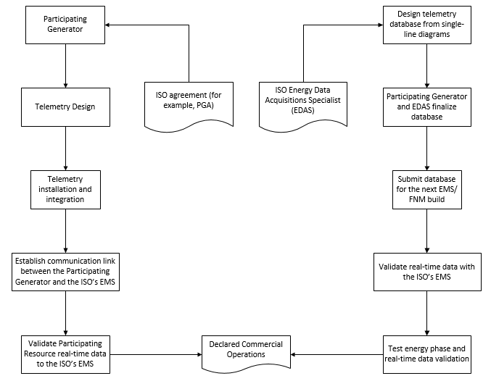
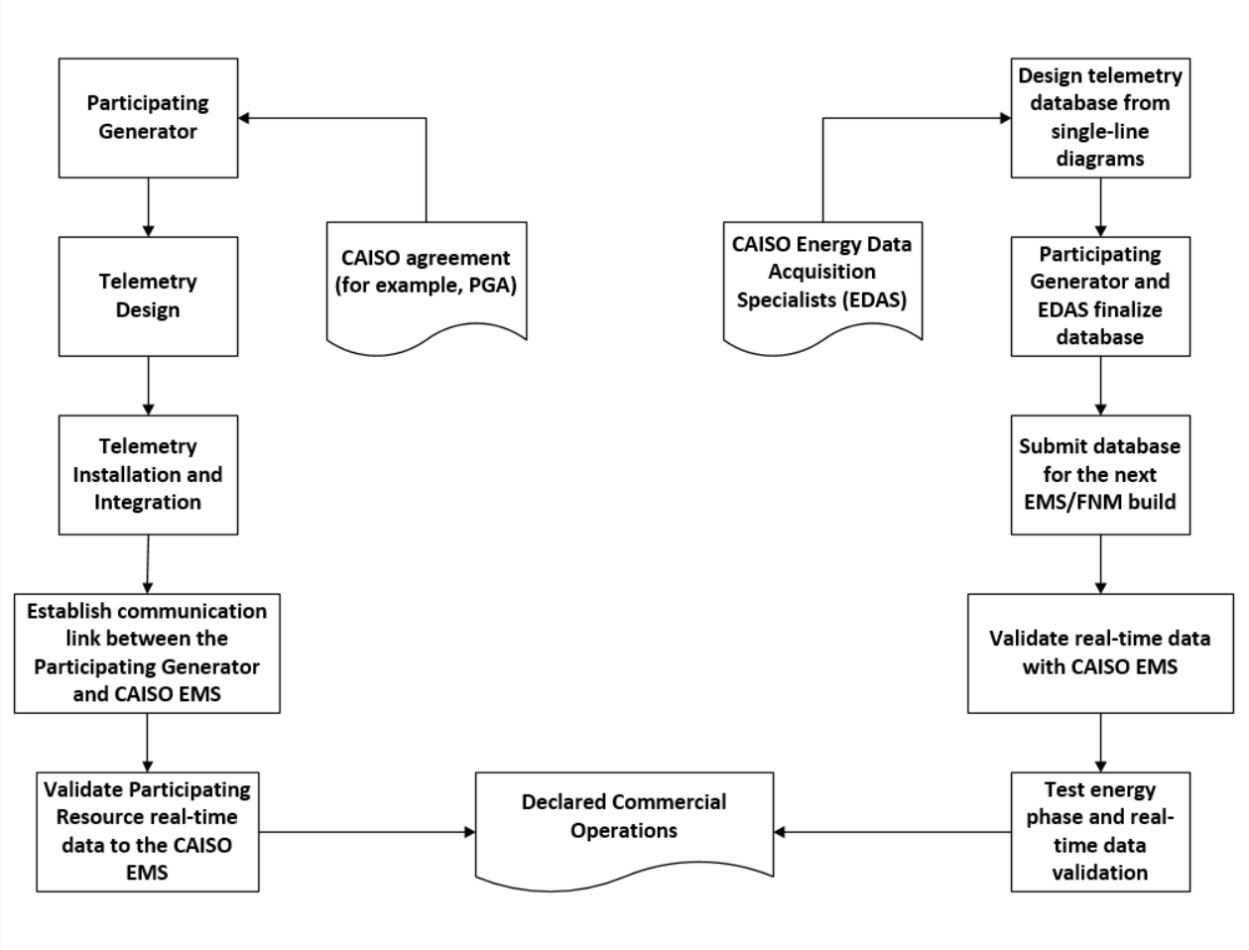

Flow of Real-Time Data
Exhibit 2-2 illustrates the flow of real-time telemetry data between resources and the CAISO’s EMS and from the CAISO’s EMS to other CAISO systems.
Exhibit 2-2: Overview of Real-Time Telemetry Data Flow
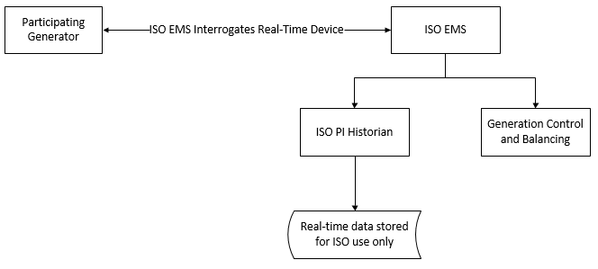
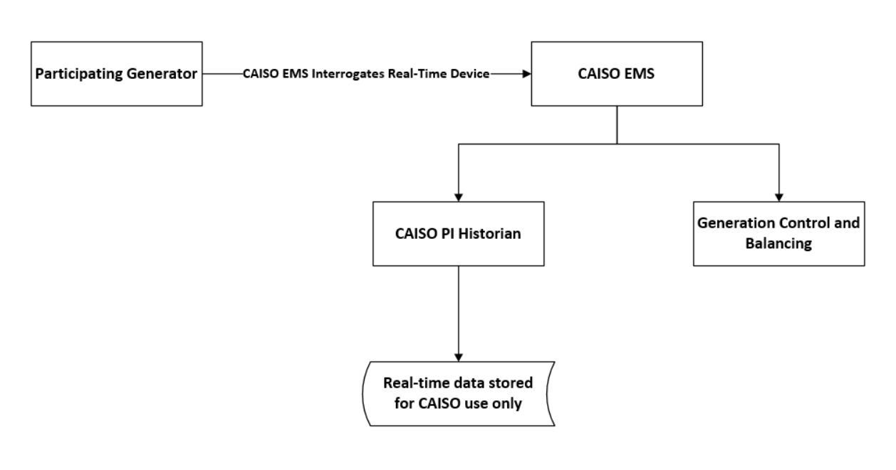

CAISO Responsibilities
This section provides an overview of CAISO responsibilities:
- A description of the installation and point-to-point validation process for telemetry facilities;
- A description of the documentation requirements;
- A description of the testing and completion requirements.

Overview of CAISO Responsibilities
Section 7.6.1(d) of the CAISO Tariff gives the CAISO the authority to direct operations of Resources required to control the CAISO-Controlled Grid and to maintain reliability by ensuring that sufficient Energy and Ancillary Services are procured through CAISO markets. This provision requires each Participating Resource to take, at the direction of the CAISO, actions that the CAISO determines are necessary to maintain the reliability of the CAISO-Controlled Grid. Such actions include (but are not limited to) the provision of communications, telemetry and direct control requirements, including the establishment of a direct communication link from the control room of the Resource Facility to the CAISO in a manner that ensures that the CAISO will have the ability to direct the operations of the Generator as necessary to maintain the reliability of the CAISO-Controlled Grid, except that a Participating Generator will be exempt from these requirements with regard to any Conventional Unit with a rated capacity of less than ten (10) MW, unless that Unit is certified by the CAISO to provide Ancillary Services. Appendix Q of the CAISO Tariff describes the telemetry requirements for Eligible Intermittent Resources (EIR) (i.e. solar and wind) and Hybrid Resources with a renewable component of 1MW or larger. Appendix A of the CAISO Tariff under Participating Generator describes the threshold for telemetry being required from 0.5MW or larger (optional) and 1MW or larger..

Exceptions to Direct Telemetry
A Participating Generator will be exempt from requirements for direct telemetry for any Generating Unit with a rated capacity of less than 10MW, unless that Generating Unit is certified by the CAISO to provide Ancillary Services. Appendix Q of the CAISO Tariff describes the telemetry requirements for EIRs (solar and wind) and Hybrid Resources with a renewable component of 1MW or larger. Appendix A of the CAISO Tariff defines the MW thresholds for a Participating Generator that an EIR resource that is less than 1.0MW and greater than 0.5MW has the option to participate in the CAISO markets.

Direct Telemetry Validation
The CAISO has overall responsibility for validating real-time data collected through direct telemetry. The CAISO executes this responsibility partially through requirements placed on the Participating Generator (or aggregator), which may include responsibilities satisfied by the Scheduling Coordinator for the resource. This Section summarizes the respective certification responsibilities of the CAISO and the Participating Generator (or aggregator, or SC, as applicable).

Overview of Telemetry Installation Validation Process
Exhibit 3-1 illustrates the overall validation process for telemetry facilities.
Exhibit 3-1: Telemetry Installation Validation Process
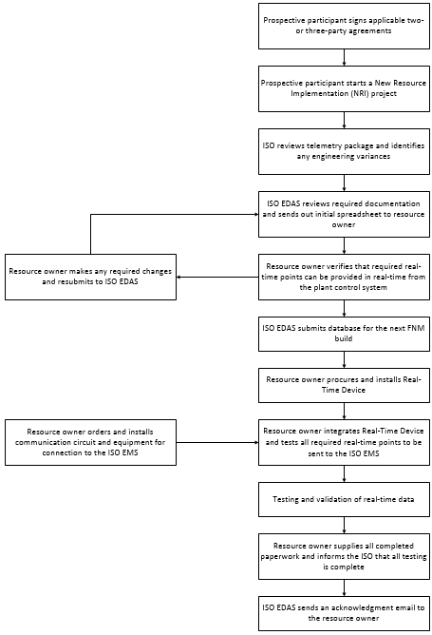
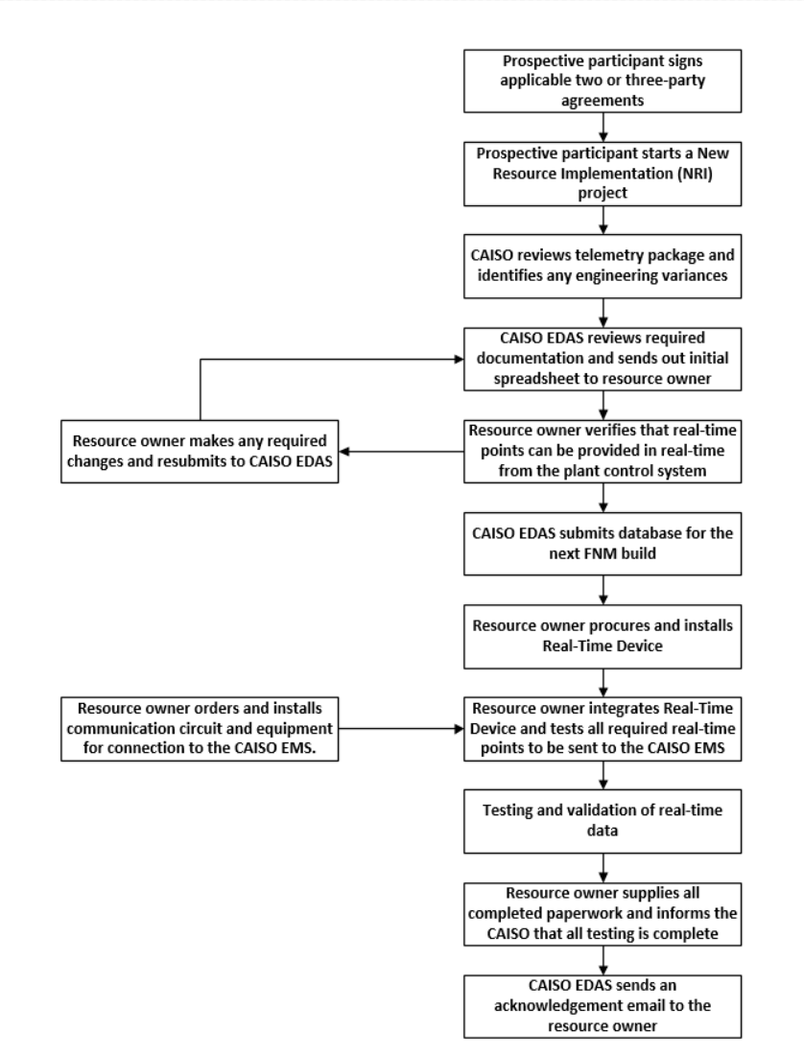

CAISO Certification Responsibilities
The CAISO does not accept real-time telemetry data from a resource unless that telemetry data is produced by telemetry facilities that have been validated in accordance with the CAISO Tariff and this BPM.

Documentation Requirements
To initiate the submission process in the scheduled FNM build and for auditing purposes, the prospective Participating Generator must provide the following information through the NRI process:
Schematics
For Generating Units, the prospective Participating Generator must provide all single-line diagrams that depict the Generating Unit connecting to the CAISO-Controlled Grid. Such drawings must be dated, bear the current drawing revision number, and show all wiring, connections, and generator equipment devices in the circuits.
Schematics requirements
Detailed station single-line drawings should show:
- How generators, transformers, and aux transformers are connected;
- All breaker and disconnect names, collection busses, showing CAISO revenue meter, PT and CT locations;
- How the station is interconnected to the CAISO-Controlled Grid.
These schematics must be of the type released for construction and stamped by an Electrical Professional Engineer; that is, the drawings are of a type used for electrical construction permitting purpose with the local permitting agency.
For existing Generator Units (Qualifying Facilities or conversions), all drawings will be as-built drawings depicting CAISO revenue metering. The Participating Generator can hand-draw the new CAISO revenue meter and any other information covered below for the purpose of fulfilling these requirements. The CAISO cannot accept facsimile representations for revised drawings; the submitted revisions must include the original drawings as well as new as-built drawings with all modifications indicated and including an Electrical Professional Engineer stamp.
Other reference information is required but limited to:
Generator data
- MVA rating
- Rated power factor at Pmax
- Nominal terminal voltage
- Reactive power capability curve (limits)
- Terminal voltage control target/range
Transformer Data
- MVA ratings (normal and emergency ratings in different seasons)
- Nominal voltages for all terminal sides
- Impedances (listing voltage base and MVA base where the impedance is calculated)
- LTC data (if applicable):
  - Max TAP and min TAP
  - Voltage control range
  - TAP step size and range
  - Normal TAP position
Generator Tie Data
- Line impedance
- MVA ratings (normal and emergency ratings in different seasons)
Breaker Data
- A breaker that is normally open must be shown in the diagram
Aux Load
- MW and Mvar level
Reactive support devices (shunt capacitor/reactor, SVC, synchronous condenser)
- Rated nominal voltage
- Rated Mvar capacity
- Number of banks and size of each bank if it has multiple banks
- Voltage control target/range
- Database submission process
- FNM build process
- Meter to Point of Delivery (POD), where the POD differs from the meter location
Additional Documentation
- See the NRI process under Resources for all additional document submission required to enter the FNM build.
- Refer to the Metering and Telemetry webpage for a Checklist of Drawing Requirements.

CAISO Review of Documentation
The Participating Generator must provide all required documentation for an FNM build.
- A Participating Generator who does not deliver required documentation within the FNM build timeline might have to wait until a future FNM build to participate in CAISO energy markets according to published timeline dates.
- The Participating Generator has a responsibility to notify an CAISO Energy Data Acquisition Specialist within 24 hours of discovery concerning any discrepancies between documentation on file and actual telemetry installation.

Communications

Overview of Communications Objectives
The CAISO technical operations systems architecture, implemented to carry out resource monitoring and control, incorporates two central systems comprising the CAISO’s EMS and operating at each CAISO location. The CAISO’s EMS has two primary functions:
- Provides AGC and operator dispatch support for monitoring and control of each Participating Generator;
- Provides for the monitoring of the transmission system within the CAISO Balancing Authority Area.
In order for the CAISO to comply with its responsibilities, the Participating Generator is required to install a DNP3-capable Real-Time Device (as described in this BPM) that meets CAISO functionality, reliability, and security objectives. The Real-Time Device establishes a real-time data interface between the Participating Generator’s local control systems and the CAISO’s EMS. The Participating Generator can validate its own control system to interface with the CAISO’s EMS; see the Real-Time Device Validation Procedure under References.

Choice of Connection Methods
The CAISO recognizes that Participating Generators require choice in the technical methods available to them to connect to the CAISO in order to provide direct telemetry in support of CAISO reliability and security objectives.
Historically, the CAISO envisioned and realized an ECN as a SCADA communications network for the Western Interconnection. Over time, the CAISO has continued to mature the ECN as a reliable digital communications network to support telemetry directly to generators as well as to revenue meters and between SCADA control centers.
The ECN supports the reliability and availability of critical grid operations and mitigates risks associated with public networks by providing more bandwidth assurance and higher service levels. The CAISO has recognized that the ECN natively does not assure protection against unauthorized access to or modification of customer data; the CAISO therefore provides an option for encrypting and digitally signing communications between the CAISO EMS and Real-Time Devices at Participating Generators in the form of SSL/TLS and X.509 digital certificates. The combination of authenticating and digitally signing communications for direct telemetry has provided a kind of non-reputability for instructions that the CAISO sends to generators – assurance on both sides in the delivery and receipt of critical communications such as AGC.
Over time, the reliability of the public Internet has improved but cyber threat to public networks has increased. Concurrently, the operational cost of leasing use of semi-private networks such as the ECN has increased relative to the cost of employing the various software-defined security overlays now available on public networks for connecting remote locations. Driven by Cloud computing, public networks continue to evolve to support secure and cost-efficient interconnection. The CAISO continues to adapt to provide increasingly more cost-effective communications options that reduce barriers to participating in CAISO markets.
Telecommunication options continue to evolve rapidly to meet customer demand and competitive constraints. The same companies that support the retail Internet support the increasingly digitally interconnected North American reliability and energy infrastructure. Digital security continues to evolve to meet higher levels of risk and threat; consequently, communications options available to Participating Generators continue to evolve to include network overlays that assure the confidentiality, integrity, and availability of the information required to secure the market-driven grid.
In 2016, the FERC approved a new type of CAISO market participant called a Distributed Energy Resource (DER) Aggregate (DERA). The aggregation point is a market resource. Participants in the market asked the CAISO to evaluate new options for securing DERA telemetry in order to reduce barriers to entering CAISO markets. Specifically, prospective participants sought to use their existing Internet broadband, instead of the ECN, to the CAISO; these participants also requested an alternative to participant-managed PKI. The CAISO has responded by adding a communication option secured on the public Internet which requires the use of a digital certificate.

Communication Context Diagram
This section describes the main communication options available to Participating Generators in the CAISO Balancing Authority Area. Participating Generators must choose whether to connect over the ECN or over the public Internet to receive DNP3 polls from the CAISO’s EMS. For non-ECN connections, Participating Generators can choose between an IPsec connection provided by AT&T or Internet Service Provider with a static IP range.
Exhibit 4-1 depicts the three communication options available to Participating Generators. There is no attempt to depict a complete communication diagram with all network equipment and servers; the purpose of the diagram is only to depict context for use of the ECN or the public Internet as well as where participant-managed digital certificates are required. The four communications options are:
- The Participating Generator leases a T1 connection to the ECN from AT&T and purchases a router with a T1 interface; this option requires an SSL/TLS digital certificate and the participant can optionally contract with AT&T to have the router managed and maintained.
- AT&T installs an ANIRA IPsec VPN gateway at the Participating Generator’s site to backhaul data over the public Internet to the ECN; the Participating Generator does not need a T1 connection to the ECN but does need to provide a broadband connection and manage an SSL/TLS digital certificate.
- The Participating Generator leases an Internet Service Provider (ISP) connection to the Internet from any ISP and purchases a router. This option requires an SSL/TLS digital certificate and the participant can optionally contract with the ISP to have the connection managed and maintained.
Exhibit 4-1: Context Diagram for Communications Options for Direct Telemetry
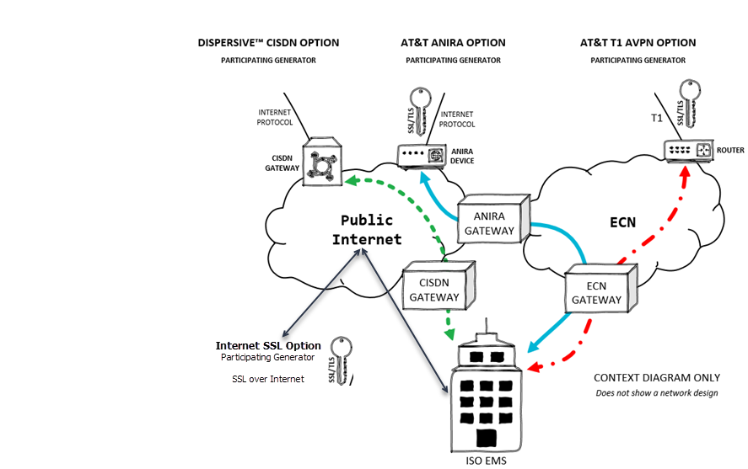

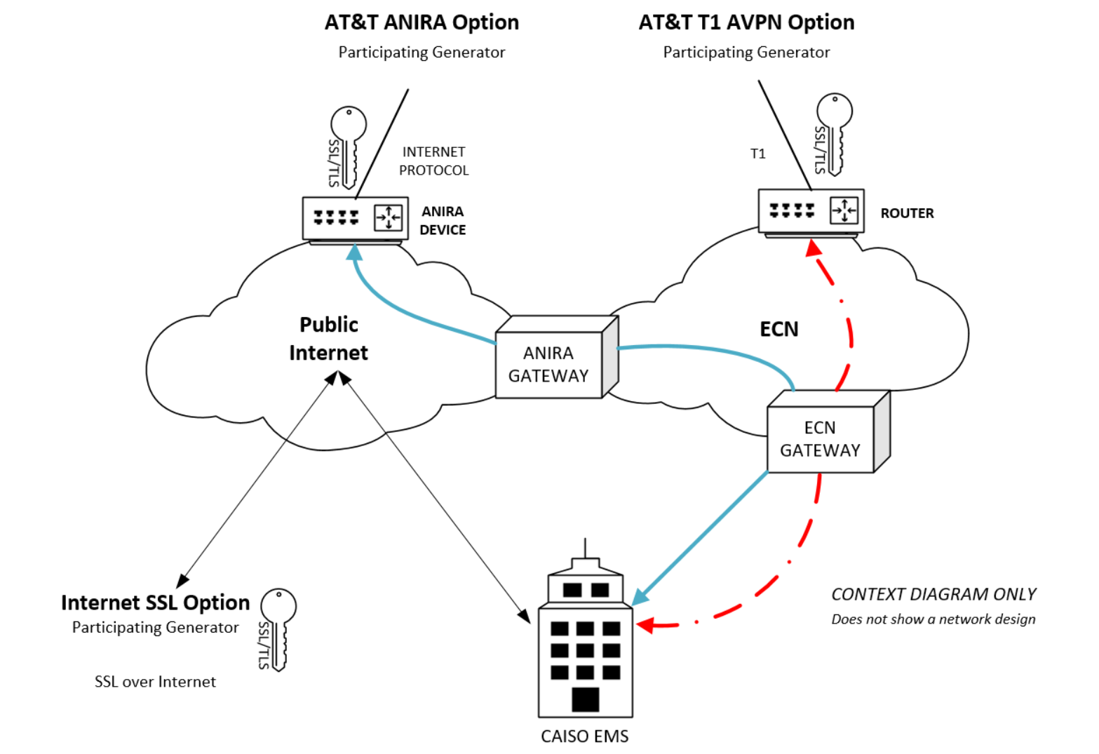

Main Communication Options
Table 4-2 shows the main requirements for each connectivity/security requirement as Yes (required) or No (not required).
Table 4-2: Main Requirements for Each Communication Option for Direct Telemetry
Connectivity/Security Requirement | AT&T Leased  T1 Line | AT&T ANIRA  IPsec VPN | Internet Service Provider
Participating Generator Leases ECN Connection | Yes | No | No
Participating Generator Provides Broadband Internet Connection | No | Yes | Yes
Participating Generator Installs an CAISO-Issued Digital Certificate | Yes | Yes | Yes

Detailed Communication Options
Table 4-3 provides a detailed comparison of communications options.
Table 4-3: Detailed Comparison of Communication Options for Direct Telemetry
Connectivity Option | AT&T Leased T1 Line | AT&T ANIRA IPsec VPN | Internet Service Provider
Connectivity | Participant leases a T1 connection to the ECN and provides a router with a T1 interface; the participant’s site must be protected by a firewall | AT&T installs an ANIRA IPsec VPN gateway at the participant’s site to backhaul data over the public Internet to the ECN; the participant provides a broadband connection | ISP provides gateway at the participant’s site or control room to backhaul data over the public Internet; the participant provides a broadband connection
Encryption | Data encryption provided from the participant’s SSL/TLS gateway to the CAISO using a participant-managed, CAISO-provided, periodically expiring X.509 digital certificate | Data encryption provided from the participant’s SSL/TLS gateway to the CAISO using a participant-managed, CAISO-provided, periodically expiring X.509 digital certificate; network encryption over the public Internet to the participant’s ECN router provided by the ANIRA gateway | Data encryption provided from the participant’s SSL/TLS gateway to the CAISO using a participant-managed, CAISO-provided, periodically expiring X.509 digital certificate
Time to Provision | Allow three months | Allow three months | ISP order processing time
Maintenance of Digital Certificates | The participant manages periodic renewal of an CAISO-provided X.509 digital certificate | The participant manages periodic renewal of an CAISO-provided X.509 digital certificate | The participant manages periodic renewal of an CAISO-provided X.509 digital certificate
Router Maintenance | The participant can optionally contract with AT&T to manage the ECN router | Maintenance of the ANIRA gateway is included in the monthly service cost | The participant can optionally contract with ISP for maintenance
Periodic Costs | Monthly cost for T1 service; participant can manage the ECN router or pay AT&T to manage it; possible monthly service costs for a branded Real-Time Device | Monthly cost for ANIRA service; possible monthly service costs for a branded Real-Time Device | Monthly cost for managed ISP service
Additional Costs | One-time costs for a Cisco router, a firewall, and either a participant-managed SSL/TLS gateway or a branded Real-Time Device (with possible associated monthly service costs) | A one-time cost for either a participant-managed SSL/TLS gateway or a branded Real-Time Device (with possible associated monthly service costs) | A one-time cost for ISP hardware
Ruggedized Gateway Available | Yes/No | Yes/No | Yes/No

Ruggedized Gateway Available
The ruggedized construction option available for the types of connections in fore mentioned option refers to resistance to shock and vibration as well as a wide range of operating temperatures. The following suggested ruggedized parameters can be found in many network gateways and it is the option of the interconnection customer to determine the need for ruggedized equipment. The CAISO does not mandate ruggedized equipment to be installed.
- Temperature range -13°F to 158°F (-25°C to 70°C);
- Resistance to shock (50 G_{rms});
- Resistance to vibration (5 G_{rms});
- Protection against overcurrent, overvoltage, and electrostatic discharge.

CAISO Security for Direct Telemetry

Data Confidentiality
Information transmitted via the Real-Time Device from a Participating Generator to the CAISO’s EMS will be treated by the CAISO as the Participating Generator’s confidential information in accordance with the CAISO Tariff.

Network Security Principles and Best Practices
The CAISO documents the following principles and best practices as a guideline for Participating Generators and in the spirit of NERC CIP compliance to which they might already be subject.
- Information is a critical asset for the CAISO.
- Protecting information assets from unauthorized or incorrect use or modification, destruction, or disclosure requires planning, teamwork, cooperation, and vigilance.
- Network access must be provisioned and maintained in such a way that only authorized users are given access to information and only with the tools required for the job.
- ECN Provider Edge Routers must not peer with Customer Edge Routers managed by Participating Generators.
  - This means that AT&T routers must not share ECN routes with ECN routers managed by Participating Generators.
  - The practical meaning of this best practice is to minimize risk to other Participating Generators on the ECN at large.
- The ECN must not bridge to the public Internet and vice versa.
  - The practical meaning of this best practice is that a device at the Participating Generator's site must not be dual homed, with one network interface connected to the ECN and the other network interface connected to the public Internet.
  - The reason for this best practice is that a device compromised by malware from a less trusted network can convey the destructive payload of that malware to more trusted network by means of the physical device that bridges the two networks.
  - A firewall that protects the device can securely multi-home the networks that it controls.
- The Participating Generator owns security at the entities facility where the ECN is installed.
  - Perimeter routers connecting the Participating Generator to the ECN must use ACLs to restrict both ingress (inbound) and egress (outbound) traffic.
  - Ingress ACLs on ECN routers must be designed to allow only trusted devices and protocols.
  - Egress ACLs must be designed to allow only traffic from assigned local IP addresses.
- Participating Generators are encouraged to review security best practices described in NIST SP 800-82 (see References), particularly in the section called Network Segmentation under ICS Security Architecture.

Communication Security Characteristics
Communication of direct telemetry to the CAISO’s EMS must be secure. All communication options are acceptable up to 1200MW per connection and 25 aggregated resources per Real-Time Device. Beyond those limits, the CAISO requires a second network connection.
Security has four main components:
- Availability – Refers to reliability and uptime.
- Data Integrity – Refers to protection against unauthorized data modification.
- Data Confidentiality – Refers to protection against unauthorized access to data.
- Authenticity – Refers to the authentication and authorization of business transactions (one example of a business transaction is a SCADA set-point instruction).
The ECN provides a high level of availability, reliability, and uptime, but, without additional security overlays, it does not provide integrity, confidentiality, or authenticity.
As Cloud architecture evolves to support higher levels of availability and reliability, VPN technologies are adapting to provide equivalent uptime over software-defined networks (SDN). Advantages of SDN include real-time response to network congestion or compromise to assure packet flow and enhanced capabilities to aggregate multiple types of broadband links to provide link failover as well as higher throughput. .

Data Integrity
Protecting the integrity of SCADA communications against network eavesdropping and MitM attacks helps assure the health of an economy that increasingly depends on highly reliable digital delivery of electricity through markets. This means that cybersecurity protections mitigate the threat of unauthorized modification or interception of SCADA instructions between the authorized sender (the CAISO’s EMS) and the authorized receiver (the Participating Generator’s Real-Time Device). The electric grid cannot be reliable without integrity assurance.

Data Confidentiality
Data confidentiality is typically assured by data encryption, an algorithmic process for rendering data undecipherable to users or identities who are not authorized to decrypt it. Confidentiality is broadly important for all data owned by Participating Generators (as protected by the CAISO’s Tariff), but it is particularly important for data from the revenue meters through which grid reliability is coupled with the mechanisms of deregulated markets. The CAISO enforces data encryption either through SSL/TLS digital certificates managed in software applications by Participating Generators or directly through network automation as part of a managed service provided to Participating Generators.

Authenticity
Authenticity requires some means of proving identity, which could be a machine identity or a human identity and could refer either to the sender or the receiver of a business transaction. In the context of this BPM, identity refers either to the CAISO’s EMS (sender) or the Participating Generator’s Real-Time Device (receiver).
The CAISO provides two options for assuring the authenticity of business transactions:
- X.509 digital certificates for sender and receiver form a mutually authenticated and encrypted SSL/TLS network transport channel for SCADA instructions. CAISO-issued participant-managed digital certificates provide this option either over leased T1 lines connected to the ECN, ISP or through the managed ANIRA service.
- Automated just-in-time data encryption authorizes pre-authenticated network identifies to complete a transaction. The quality of “just in time” refers to encryption keys that change periodically to defeat persistent network eavesdropping.
A combination of authenticity and integrity can provide a level of digital assurance that information has arrived at its intended destination. The relevance of this for direct telemetry is assurance, in the form of non-reputability, that a Participating Generator received an instruction from the CAISO’s EMS.

Communication Security Protocols
Real-Time Devices may support a number of standard available plant interface protocols. The Participating Generator has the option of designing its own integration solution for the Real-Time Device or hiring an integrator of its choice. The encryption options below can be easily achieved by either approach. Participating Generators should contact an CAISO Energy Data Acquisition Specialist for consultation before designing or installing a Real-Time Device.
The protocol required between the Participating Generator Real-Time Device and the CAISO’s EMS is DNP3 with one of the following encryption options:
- SSL/TLS (*At this time SSL/TLS encryption is the only available option)
  - This option requires that the Participating Generator manage an X.509 digital certificate that is issued by the CAISO and periodically requires renewal.
  - The connection from CAISO EMS to the RIG can be one of the following options:
    - A broadband ISP connection secured by an ANIRA IPsec VPN gateway in line with a Participating Generator’s existing broadband link; or
    - A broadband ISP connection gateway in line with a Participating Generator’s existing broadband link; or
    - An ECN connection provisioned by AT&T.
  - The CAISO supports communications via TLS version 1.2.
    - For communications using an internet pathway, Real-Time Devices should utilize the highest TLS version supported by the CAISO. Effective 6/30/21, the CAISO will no longer support TLS versions 1.0 or 1.1 for this communication pathway.
    - For communications using the CAISO ECN pathway, Real-Time Devices should utilize the highest TLS version supported by the CAISO. Effective 6/30/22, the CAISO will no longer support TLS versions 1.0 or 1.1 for this communication pathway.
    - Effective 6/30/21, the CAISO will no longer accept communications from Real-Time Devices utilizing RC4 or CBC ciphers.
  - In the interest of securing communications for the vast majority of participants, CAISO reserves the right to remove broken/legacy TLS options/ciphers/protocols/certificates/etc prior to completion of the BPM Change Management process when such change will only impact a small minority of participants with legacy unsecure implementations and security is deemed to be at risk.

Communication and Network Documents
DNP3 communications from a Real-Time Device to the CAISO must be encrypted using the SSL/TLS digital certificates issued by the CAISO and managed by the Participating Generator;. PKI agreements and External Network Guidelines govern encryption using SSL/TLS over the ECN. PKI agreements also apply to connections of a Real-Time Device over the public Internet. This BPM requires adherence to the following security agreements (see References).
- For AT&T-provisioned connections (ECN, ISP, or ANIRA), the Participating Generator must sign the Certificate Practice Statement for Basic Assurance Certification Authority.
- For all connections, the Participating Generator must sign the External Network Guidelines Document.
- The Participating Generator is required to follow policy described in the Information Security Requirements for the Energy Communication Network (ECN).
- Form submission with the proper filename convention is a precursor to opening communication from the CAISO’s EMS. See New Resource Implementation Contact in References for submission e-mail address.

Connected Entity Service Guides
For connecting to the CAISO EMS, Participating Generators (as Connected Entities) can choose among two options: AT&T, ISP.
- The ECN connection requires a T1 circuit provisioned by AT&T.
- For connecting to the CAISO EMS over the public Internet, Participating Generators have two options:
  - AT&T ANIRA
  - ISP
- A connection option above is required for connecting a Real-Time Device to the CAISO EMS.
- Use of CAISO-issued digital certificates is required. This BPM references service guides for the AT&T option (see References).
- AT&T Connected Entity Service Guide
  - A direct ECN connection requires an AT&T-provisioned T1 circuit.
  - The AT&T ANIRA connection uses a Participating Generator’s existing Ethernet or cellular IP broadband link, obtained through the local ISP, to connect to the ECN; there is no requirement for a T1 circuit.
  - Both options require use of an CAISO-provisioned SSL/TLS digital certificate to establish an encrypted communication channel over the ECN, which natively has no encryption.
    - The ANIRA connection is encrypted between the Participating Generator and the ECN but not over the ECN to the CAISO EMS; SSL/TLS provides encryption over the ECN.
    - The T1 connection is encrypted between the Participating Generator and the CAISO EMS over the ECN using SSL/TLS.
- ISP Connected Entities please refer to their service guide

Reliability

Redundant Circuits
The Participating Generator may optionally implement a diversely routed secondary communications circuit. The CAISO recommends using redundant circuits when feasible. The procurement of redundant circuits and paths is the Participating Generator’s responsibility and the redundancy must be managed by the connection service provider.

Data Validation
All telemetry data reported from the Real-Time Device must be within +/-2% of the true value. The CAISO or its designee may inspect the Participating Generator’s Real-Time Device and related facilities to verify the accuracy and validity of all CAISO telemetry. All data telemetry provided through the Participating Generator’s Real-Time Device must be tested by the Participating Generator or Participating Generator’s representative for accuracy and validity on a periodic basis as necessary to ensure that accuracy requirements are maintained. The best practice is to test all resource data annually for accuracy.

Voice Communications
Each Participating Generator in the CAISO’s market model must be able to establish normal voice communication over a dedicated voice communications circuit from the Participating Generator local control center that has immediate remote and manual control of the Generating Unit(s).
A dedicated voice communication circuit is one that is available at all times for communication purposes between the CAISO’s dispatchers and the Generating Unit’s local control center.

Communications During Telemetry Failure
In the case of telemetry failure, a Participating Generator that provides real-time data is responsible for manually communicating generation values to the CAISO on a 24x7 basis until normal telemetry is restored. See section 8.4 for additional details on this subject.

Operational Telemetry Requirements

Unit Telemetry Visibility
Each resource participating in the CAISO’s Ancillary Services markets or any Eligible Intermittent Resource or any resource providing Energy with a capacity of 10MW or greater that is not exempt pursuant to the CAISO Tariff must provide telemetry data according to the point matrix specified in Section 7 of this document and pursuant to CAISO Tariff Section 7.6.1(d).

Performance Monitoring

Direct Telemetry Timing Requirements
Exhibit 5-1 shows the performance and timing requirements for a Generating Unit connected to the CAISO EMS.
- A Participating Generator must be able to accept and begin processing direct digital control (DDC) signals (Set Points) within the CAISO time standard (two-second maximum from CAISO’s EMS to output of the Real-Time Device). The two-second maximum includes any Generator or third-party communication equipment located between the CAISO and the Participating Generator.
- A Participating Generator must be able to send data to the CAISO within the CAISO time standard (two seconds from the input of the Real-Time Device to the CAISO EMS).
- The plant controller must receive the signal from the Real-Time Device within the CAISO time standard (an additional two seconds from output of the Real-Time Device to plant controller).
- The time standards also apply in the return direction, resulting in a total maximum of eight seconds, round trip, for the signal to travel from the CAISO EMS to the plant controller and back.
- The timing requirements from the CAISO EMS to the plant control system (for example, DCS, RTU) through the use of non-CAISO communication equipment must meet the CAISO two-second time standard in one direction.
- The timing requirements from the plant control system back to the CAISO EMS through the use of non-CAISO communication equipment must meet the CAISO two-second time standard in the return direction.

Exhibit 5-1: Timing of Telemetered Real-Time Data for Generators Providing Ancillary Services or Energy Only through a Real-Time Device
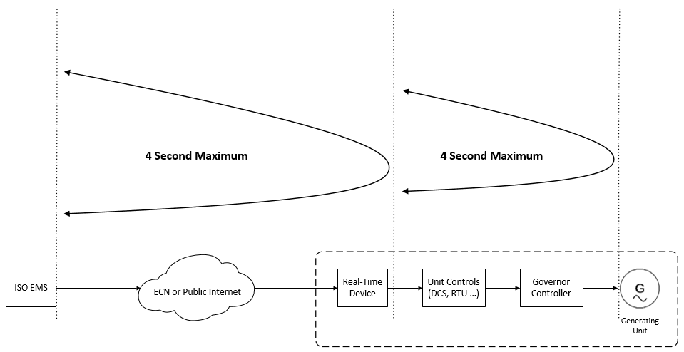

PDR Timing Requirements
The provisions of the section above apply to PDR telemetry, except that the resource telemetry requirement may be expanded to either one (1) minute when participating in the Day-Ahead, Real-Time, and Non-Spinning Reserve markets or five (5) minutes when participating in the Day-Ahead or Real-Time markets. The election for one (1) minute or five (5) minutes is applied to all locations underlying the PDR. The per-location readings that make up the resource-level telemetry will be time-aligned within any PDR resource to within a +/-30 second time accuracy compared to a resource-specific synchronization time. If a location’s telemetry source drifts outside of this band the Participating Generator is responsible for synchronizing the telemetry source. In all cases, the resource-level telemetry points must be available within Real-Time Device for the CAISO’s 4-second poll with no more than a 1-minute latency. Exhibit 5-2 highlights this timing in the 5-minute case.
Exhibit 5-2: PDR Timing, 5- Minute Case
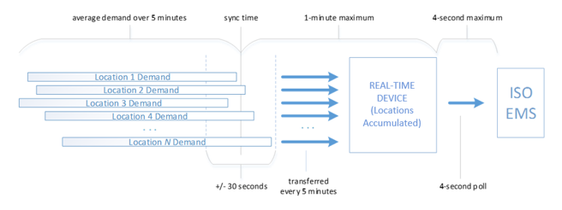
The timing referenced this section also applies to PDR participating in the Spinning Reserve Market.
Real-Time Devices providing telemetry for PDRs must provide valid data points only during the time that the PDR is in a dispatchable state, including one hour leading up to and one hour after that state. Dispatchable is defined as any time the resource has the potential for energy dispatch, specifically during day-ahead award hours and real-time energy bids.

PDR Reading Requirements
The provisions in this document shall apply to PDR telemetry, except that all references to “real-time updated value and not averaged over time” should be taken as “real-time updated value or average reading over the PDR timing interval” for PDRs.

CAISO Real-Time Communication Technical Design Options
With the recharacterization of a RIG as any Real-Time Device that meets the security and operational objectives for direct telemetry, the CAISO now supports both branded (turn-key) and non-branded (build-your-own) technical designs. Hybrid solutions are also possible. Contact an CAISO Energy Data Acquisition Specialist for consultation using the contact information in the References section of this BPM.
The CAISO is continually looking for options that will allow Participating Generators to connect to the CAISO’s EMS in a cost-effective and secure manner. A Real-Time Device can be software running on a Plant Control System or a combination of software optionally hardware on a separate device. Its function as an interface to the CAISO’s EMS can be either logically or physically segmented at the Participating Generator’s site. This section describes multiple secure options that will allow the Participating Generator’s control system to connect to the CAISO’s EMS by means of a Real-Time Device.
The CAISO’s EMS controls and monitors resource sites from two physical locations with two connections in simultaneous operation. This exchange of data is performed using Real-Time Devices either over the ECN or using a Participating Generator’s existing broadband link.

Functional Components of Real-Time Communication Options
The functional components of real-time communication options, without regard to specific implementation, are as follows.
- Plant Systems: Each plant providing Ancillary Services or Energy has a control system that obtains telemetry from Generating Units. Various measured values must be available from the Plant Control System as described in this BPM. The Plant Control System constitutes the source of the telemetry necessary to comply with the CAISO’s standards, pursuant to CAISO Tariff Section 7.6.1(d).
- Plant Interface Protocol: The interface between the Real-Time Device and the plant control system can be any protocol convenient to the control system, according to the relationship between the supplier and the Participating Generator.
- SSL/TLS Encryption Layer: With SSL/TLS, the CAISO’s EMS real-time IP DNP3 poll converts to TCP in-the-clear or serial DNP3 protocol at the resource control system. The SSL/TLS capability may reside on the Plant Control System or on separate hardware.
- Exemption from Simultaneous Connection: The CAISO may grant an exemption from the requirement to establish two simultaneous connections for an intermittent resource with a capacity less than 10MW. For resources with a capacity of 10MW or greater the SSL/TLS option must meet the CAISO standard for simultaneous connections.
- ECN Connection: The Energy Communications Network (ECN) is a semi-private AT&T MPLS communications network option for telemetry from the Real-Time Device to the CAISO’s EMS. AT&T provisions access to the ECN. The ECN natively has no encryption. . AT&T can provision ECN connectivity either as a T1 circuit with a customer-provisioned router or as an ANIRA IPsec VPN tunnel to the ECN. The ANIRA gateway has Ethernet and cellular IP capability.
- Internet Connection: The connection option for the public Internet is for real-time data through an ISP for the purpose of telemetry in the same manner as the ECN. The ANIRA option supports this method.
- Securing DNP3 over TCP/IP: The DNP3 protocol communicated over the TCP/IP transport must be secured. The CAISO’s EMS does not use the DNP3 SA (Secure Authentication) extension but achieves the same, plus encryption, using the following method:
  - SSL/TLS with a customer-managed and periodically expiring digital certificate provisioned by the CAISO
- CAISO EMS: All telemetry arrives at the CAISO’s EMS encrypted over TCP/IP via either the ECN or an ISP network.

Transport Options
The CAISO supports three transport options for direct telemetry:
- ECN with T1 leased circuit.
- Public Internet with ANIRA IPsec VPN backhaul to ECN.
- Public Internet.
Option one requires the Participating Generator to lease a T1 circuit from AT&T to connect to the ECN. This option does not use the public Internet. The Participating Generator must manage an CAISO-issued digital certificate to secure the communication link.
Option two requires the Participating Generator to provide a broadband circuit and to contract with AT&T to install an ANIRA IPsec VPN gateway to connect to the ECN. The Participating Generator does not need to lease a T1 circuit. The Participating Generator must manage an CAISO-issued digital certificate to secure the communication link.
Option three requires the Participating Generator to provide a broadband circuit to the Public Internet. The Participating Generator does not need to lease a T1 circuit and but does need to manage an CAISO-issued digital certificate to secure the communication link.

Transport Conceptual Diagrams
The following diagrams conceptually depict each of the three transport options described above. These diagrams do not depict the requirement for a Real-Time Device to receive two polls simultaneously from each CAISO EMS.

ECN with T1 leased circuit.
In Exhibit 5-3, Customer Edge refers to a router with a T1 interface that a Participating Generator must purchase to connect to the ECN through the AT&T Provider Edge router. The Participating Generator may optionally contract with AT&T for management of the Customer Edge router. The key symbol labeled with SSL/TLS shows use of an CAISO-issued digital certificate that the Participating Generator must manage on the Real-Time Device.
Exhibit 5-3: Transport Option – ECN with T1 Leased Circuit
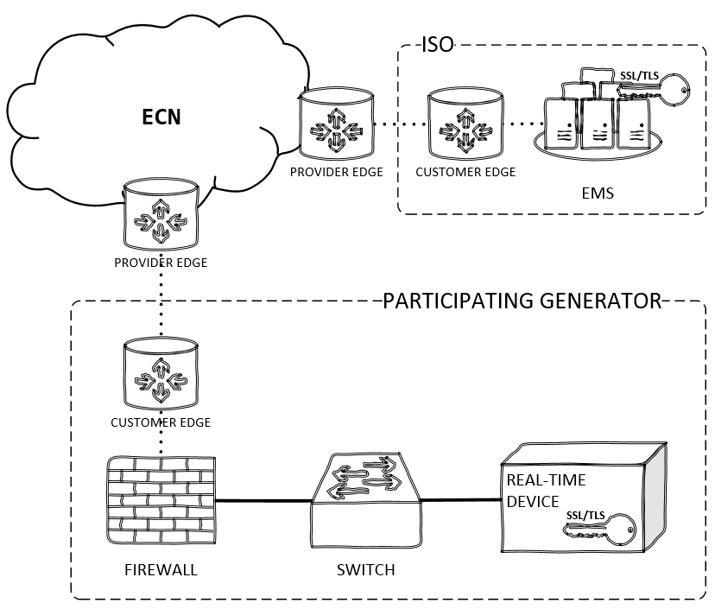

Public Internet with ANIRA IPsec VPN backhaul to ECN.
Exhibit 5-4 depicts the IPsec tunnel between the Participating Generator’s ANIRA gateway and the ANIRA gateway (or concentrator) on the ECN edge. The Participating Generator provides a broadband connection that serves as the site’s gateway for the IPsec tunnel over the public Internet between the generator site and the ECN. The key symbol labeled with SSL/TLS shows use of an CAISO-issued digital certificate that the Participating Generator must manage on the Real-Time Device. ANIRA supports Ethernet and cellular IP connections.
Exhibit 5-4: Transport Option – Public Internet with ANIRA IPsec VPN Backhaul to ECN
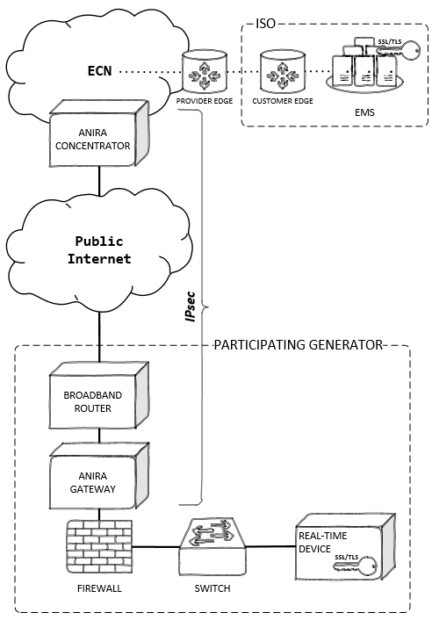

Direct Telemetry Hardware Options
The purpose of this section is to illustrate hardware options for direct telemetry. Participating Generators have the option to build their own Real-Time Devices to interface to plant devices. Unless using the ANIRA transport option, Participating Generators also have the option to install or build their own security devices, as long as those devices meet CAISO security objectives. There are two security options: SSL/TLS and IPsec plus SSL/TLS..

Plant Control System Hardware Option
In this option, the Plant Control System functions as the Real-Time Device. The software can reside on the Plant Control System. The device performs an SSL/TLS connection for DNP3 data over TCP.
The CAISO’s EMS communications with the Plant Control System using the DNP3 protocol. For this option, the Plant Control System must have an outstation DNP3 protocol driver. Real-time data that comes from meters and other plant devices must reside on the Plant Control System. The security gateway handles an SSL/TLS connection.
This option must pass security validations as conducted during the CAISO’s NRI process. The CAISO does not certify Real-Time Devices; Participating Generators may use any Real-Time Device that the CAISO has tested for all required functions.
Exhibit 5-7 shows the data flow for this option. A commodity network load balancer may provide the SSL/TLS gateway.
Exhibit 5-7: Plant Control System Hardware Option
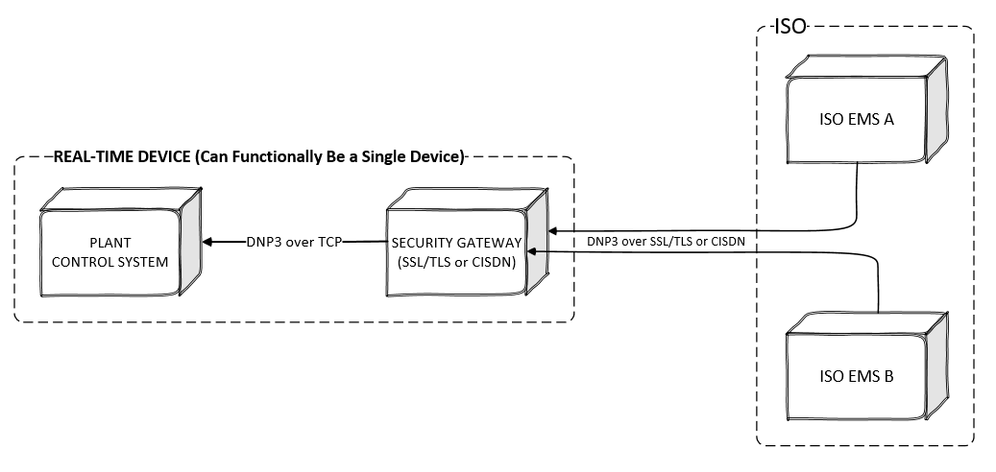
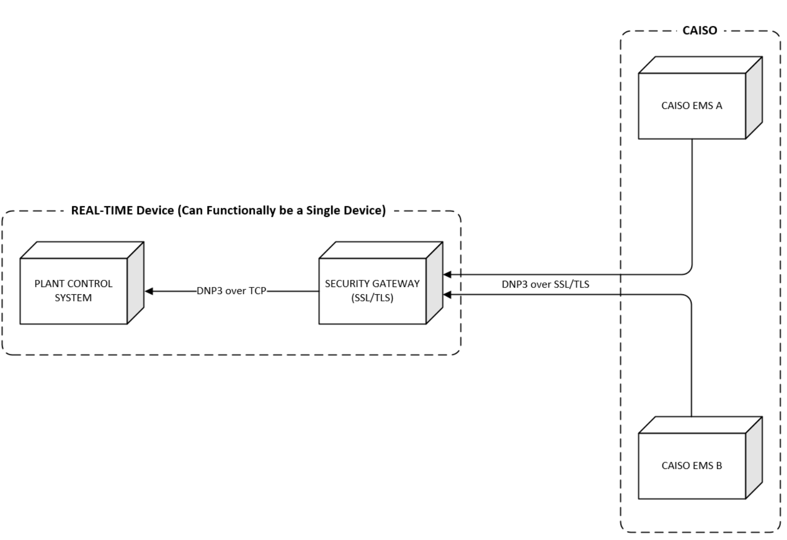

Exhibit 5-8 identifies, by number, the aspects of a serial or TCP clear-text solution. The diagram represents a high-level overview of the perceived functionality of the solution. It is provided for illustration purposes only. The interfaces, envisioned through an abstraction of the internal functionality of the hardware device, are numbered and described below.
Exhibit 5-8: Plant Control System Hardware Option Functional Diagram
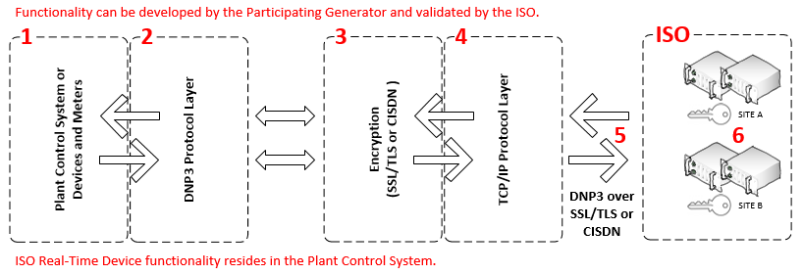
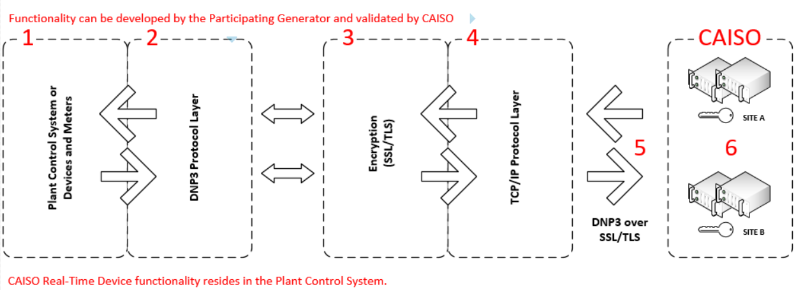
- Plant Control System: Must perform all Real-Time Device functionality described in this document.
2. DNP3 Output Interface Protocol Layer: The Plant Control System must communicate with the DNP3 subordinate protocol and support the objects and variations described in this document.
3. Encryption Layer: This layer will be an implementation of SSL/TLS using CAISO-issued digital certificates..
4. TCP/IP Output Interface Layer: The serial to IP device acts as the TCP server/connection. Once the serial to IP device has requested and established the TCP connection, the encrypted DNP3 compatible data stream passes through a TCP/IP connection over a TCP/IP network.
5. DNP3 over TCP/IP over SSL/TLS: Secure DNP3 data over TCP/IP is achieved when the encrypted DNP3 compatible data stream is transported onto the TCP/IP network. Encryption is provided by SSL/TLS.
6. CAISO Multi-Porting Capability: The security device must have one IP address with the ability to communicate with two simultaneous TCP/IP connections sourced from the CAISO’s EMS.

Real-Time-Device Hardware Option
This options consists of a Real-Time Device that functions as a protocol interface to the Plant Control System and an SSL/TLS interface to the CAISO’s EMS. The CAISO’s EMS communications with the Real-Time Device using the DNP3 protocol. This option may be used when a Participating Generator’s control system cannot communicate DNP3 protocol. The Real-Time Device provides SSL/TLS security. The CAISO does not certify Real-Time Devices; Participating Generators may use any Real-Time Device that the CAISO has tested for all required functions. Exhibit 5-9 shows the data flow for this option.
Exhibit 5-9: Real-Time Device Hardware Option
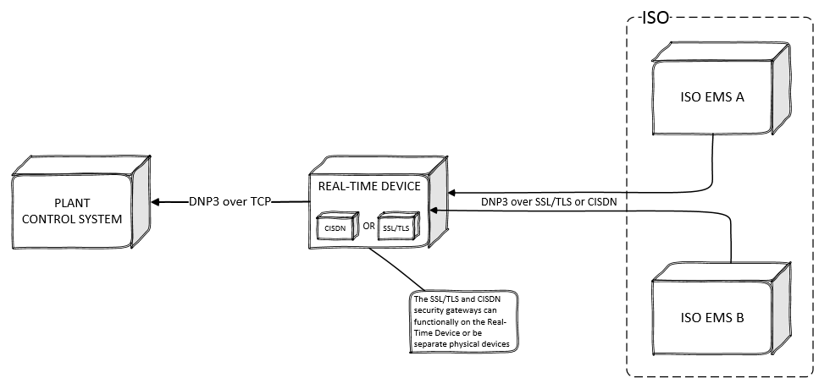
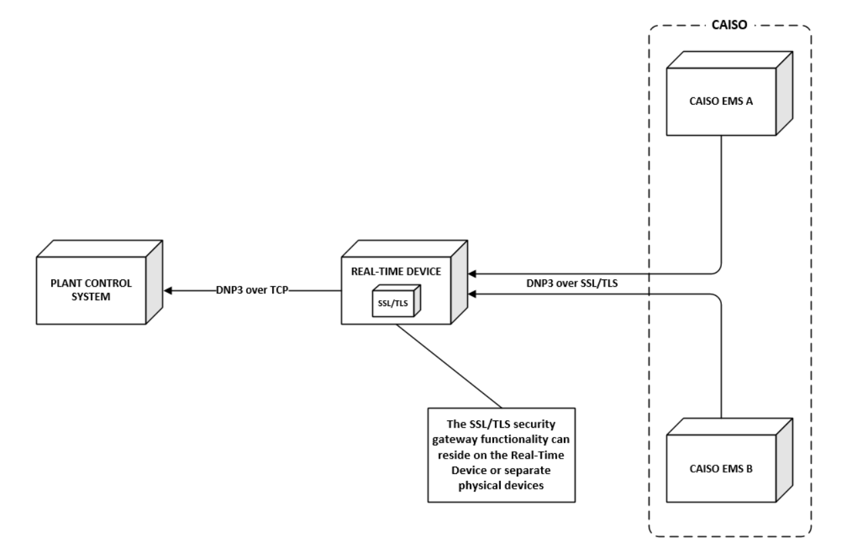
Exhibit 5-10 identifies, by number, the critical aspects of the CAISO Real-Time Device. The diagram represents a high-level overview of the perceived functionality of an acceptable Real-Time Device in a single hardware device. This diagram is an illustration only. The interfaces, envisioned through an abstraction of the internal functionality of the hardware device, are numbered and described below.
Exhibit 5-10: Real-Time Device Hardware Option Functional Diagram
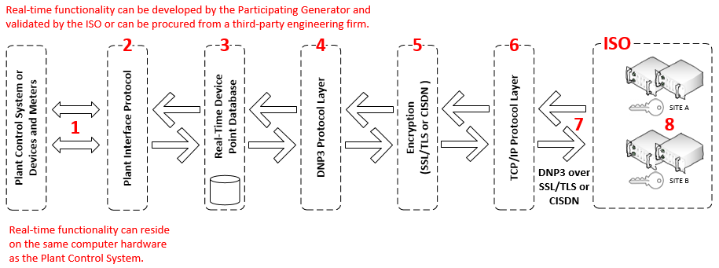
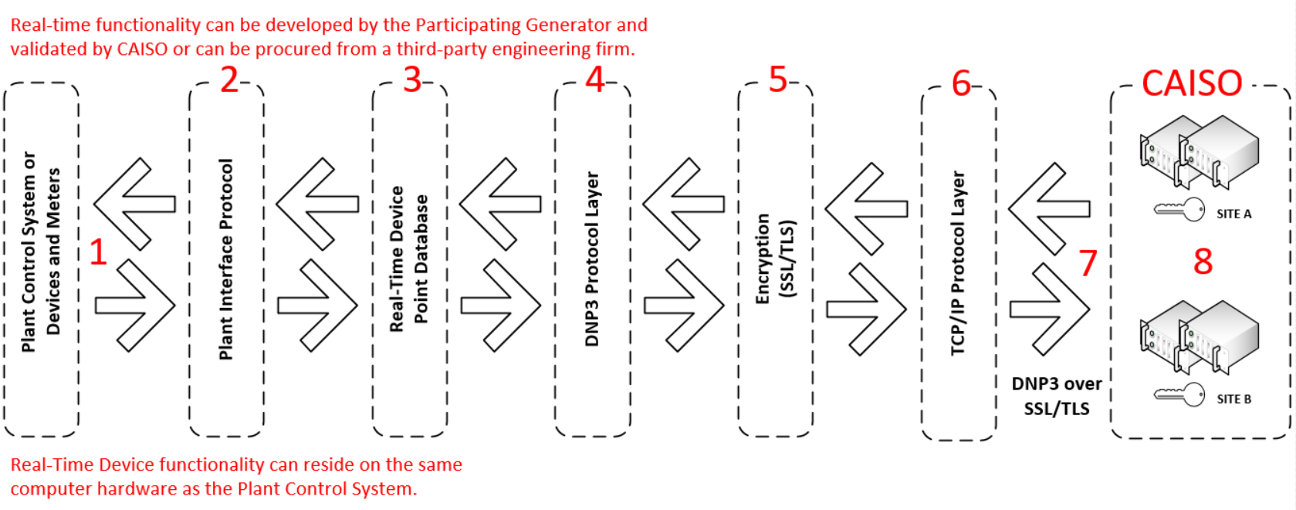
- Plant Interface Protocol: The input to the Real-Time Device is a data stream compatible with the plant systems. This may also be individual hardwired inputs.
- Internal Plant Interface Protocol Layer: The input data stream is received internally by an interface layer compatible with the plant systems.
- Real-Time Device Point Database / DNP3 Database Profile Specifics: The input data is processed internally in the Real-Time Device as data points in a DNP3-compatible database structure. Since the real-time data must be compliant with DNP3 Level 1 protocol, and can contain a database large enough to require more than a single datalink frame for a Class 1 data response, the Real-Time Device must support both static and event-type data points. The Real-Time Device is required to support polling by class.
4. DNP3 Output Interface Protocol Layer: As the DNP3 server, the Real-Time Device will parse all client requests and supply the appropriate data designated in the Real-Time Device Point Database. This is typical of a DNP3 driver storing data into the real-Time database.
5. SSL/TLS Encryption Layer: In transferring the data from the Real-Time Device to a DNP3-compatible destination, elements are encrypted by a SSL/TLS encryption interface layer using CAISO-issued basic-assurance digital certificates implemented either in the ECN or the public Internet.
6. TCP/IP Output Interface Layer: The Real-Time Device is to act as the TCP server/connection. Once the client device has requested and established the TCP connection, the encrypted DNP3-compatible data stream passes through an interface layer over a TCP/IP network.
7. DNP3 over TCP/IP over SSL/TLS: The DNP3 data stream is secured over TCP/IP using SSL/TLS encryption and transported over a TCP/IP network.
8. CAISO Multi-Porting Capability: The Real-Time Device must have one IP address that has the ability to communicate with two simultaneously connections sourced from the CAISO’s EMS.

CAISO EMS Interrogations
The CAISO’s EMS DNP3 front-end processors interrogate each Real-Time Device with DNP3 Object 60, Variations 2 for event data polling (Class 1 data). Responses shall be the event objects and variations listed below. If there is no points designated as class 1 then the CAISO will be instructed by the DNP3 Real-Time Device that protocol driver of data in another class, this is handled and inherent to the DNP3 driver.
The CAISO’s EMS DNP3 front-end processors interrogate each Real-Time Device with DNP3 Object 01 Variation 00 “digital static updates” and Object 30 Variation 00 for “analog static updates.” The Real-Time Device response must be among the Static Objects and Variations.

DNP3 Object and Variation Types for Real-Time Device Responses
Objects and Variations supported by the Real-Time Device must include, but are not limited to:
- Static: Object 1 Variation 2 (Digital)
Object 30 Variation 2 (Analog)
- Event: Object 2 Variation 1 (Digital)
Object 32 Variation 2 (Analog)
- Time: Object 50 Variation 1 (Read and Write)

- Control: Object Type 41 (Analog Setpoint) Variation 2
Important
The CAISO’s EMS DNP3 front-end processors may use DNP3 group and variations other than those listed above. All Real-Time Device solutions must be DNP3 Level 1 certified.
Deadband: The deadband must be configurable on a point-by-point basis. Below is a table of telemetry points along with their respective deadband setting. If you have any questions or a point is not reflected below, please consult CAISO EDAS for proper deadband settings.
Telemetry Point | Deadband Setting
UPMW (and all MW points as well as MXENERGY) | 0.01
SPD | 0.1
TEMP | 1
BPTMP | 0.1
PAIRD | 0.1
PRES | 0.1
DIR | 1
KV | 0.1

Quality Flag Propagation to DNP3
When a Participating Generator installs a Real-Time Device and it communicates to downstream devices that are not directly connected to the Real-Time Device, the originating device(s) shall propagate a data quality communication flag for each point to the Real-Time Device through each non-originating device. A data port alarm point may not be required; however, this will be determined by CAISO Energy Data Acquisition Specialist. Other protocols with data quality flags maybe used to propagate flags into DNP3 flags (OPC).
An originating device is one that gathers field data directly (for inputs) or issues controls directly to the field (for outputs). A non-originating device is one that obtains input data or issues control commands via a communications link from originating or non-originating devices. A reporting device is a device that acts as a DNP3 outstation, sending DNP3 messages to an upstream device.
Data from an originating device may arrive at the master via one or more data concentrator devices. In this case, each device in the communications chain, other than the master, is a reporting device. Exhibit 5-11 illustrates device identification. The terms “upstream” and “downstream” that indicate relative device hierarchy are also shown in this diagram.
Exhibit 5-11: Upstream and Downstream Device Identification
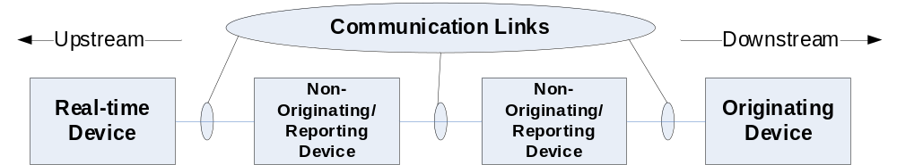

A COMM_LOST indicator indicates that there is a communication failure in the path between the device where the data originates and the reporting device on a point to point basis. This flag indicates that the value reported for the object may be stale or in bad quality. If set, the data value reported shall be the last value available from the originating device before communications were lost.
An originating device never sets this flag. A non-originating or master device sets this flag if it loses communication with the adjacent downstream device; otherwise it propagates the state of COMM_LOST flag as received from the downstream device. Once set, this flag may only be cleared when data for this point is received from the adjacent downstream device and the COMM_LOST flag received with that data is cleared.

Maximum MW Real-Time Device Limitation
The CAISO’s grid and market operations depend on data from a Real-Time Device to reliably run real-time operations, the Full Network Model, and the State Estimator. To minimize potential impact to the CAISO’s grid and market operations, the CAISO sets a maximum MW limitation. The limitation is set to protect the CAISO’s markets and grid, should a Real-Time Device failure occur.
The maximum generation that can be put on a single Real-Time Device cannot exceed 1200 MW from a physical location. This includes the ECN circuit and router. The CAISO reserves the right to review all proposed telemetry systems for compliance with this and other Real-Time Device limitations.
For Eligible Intermittent Resources and real-time Aggregators, the maximum combined generation for a single device, including the communication circuit and router, is 1200 MW.

Real-Time Device Location Requirements
The purpose of a real-time location requirement is to limit the impact of possible real-time failures to a smaller geographical area. Location limits are defined by the standard 23 Sub-LAPs within the CAISO Balancing Authority Area. The location limitation provides that only resources within a Sub-LAP can be aggregated within a Real-Time Device. The Real-Time Device shall reside within the Sub-LAP for the resources it is aggregating.
The CAISO can make an exception to the location limits for aggregating resources within a Real-Time Device if a resource is located in an adjacent Sub-LAP that does not have a Real-Time Device.
A Real-Time Device Aggregator can combine multiple physical resource locations within a Sub-LAP. The MW limitation and limitation of aggregation location to Sub-LAPs is due to the unpredictable nature of these resource types (that is, solar and wind). Only a CAISO Energy Data Acquisition Specialist may authorize an exception to location limits. The list of the Sub-LAPs is set forth in Section 19.
These limitations do not apply if a Real-Time Device Aggregator desires to transmit real-time data to the CAISO for information only. The Real-Time Device location limitations do not apply to Real-Time Devices used in the transmission of real-time data by Demand Response Providers (DRP) to the CAISO for Proxy Demand Resources.

Real-Time Device Market Resource Limitation
The purpose of a resource limit is to mitigate the impact of a Real-Time Device failure on the CAISO’s market Model State Estimator. If the CAISO loses communication with many resources at once, it may impact the CAISO’s modeling calculations. To mitigate this risk, the CAISO has set the resource limit for a single Real-Time Device to 25 Resource IDs, subject to defined MW limits.

Cost Responsibility
Each Participating Generator will be responsible for all costs incurred for Real-Time Device procurement and installation for the purpose of meeting its obligations under this CAISO BPM, notwithstanding other CAISO policies, procedures, and contracts that may affect the distribution of costs to participating parties.

Telemetry Data Points List
The following values are the minimum requirements for real-time visibility of each resource. The CAISO’s Operations & Engineering groups have approved these requirements. They are the minimum standards that will allow the CAISO to manage effectively the reliability of the grid. At any time, the CAISO may require additional points to be added to meet real-time requirements. The following points must be provided for each resource in the specified category. The Participating Generator must obtain the required point list from CAISO Energy Data Acquisition Specialists.

Point Matrix
The following pages represent the minimum point requirement matrix for each type of Real-Time Device configuration that the CAISO requires for real-time control or monitoring. The matrix specifies the telemetry points required for the following categories of resources:
AGC: Resources certified to provide Regulation in the CAISO Markets.
Spinning Reserve: Resources certified to provide Spinning Reserve in the CAISO Markets.
Non-Spinning Reserve: Resources certified to provide Non-Spinning Reserve in the CAISO Markets.
QF Conversion: Resources that are Qualifying Facilities not exempt from CAISO Tariff telemetry requirements pursuant to pre-existing agreements. Note that MW, MVAR, and voltage values are measured based on the Point of Demarcation for a Net Scheduled Resource subject to a NSPGA.
Energy Only: Resources that provide Energy only.
PDR: Proxy Demand Resources.
Solar: Solar resources.
Wind: Wind resources.
NGR: Resources that operate as either generation or load.
If a resource falls within more than one category, the Participating Generator or Real-Time Aggregator must provide the telemetry points specified for each applicable category.
Psuedo ties of Shared resources:

- Each share will be modeled as a simple generator.
- The Protocol Administrator, on behalf of the Pseudo-Tie PGA owners, will provide CAISO with separate telemetry data for the entire resource and for each share of the resource, in addition to any other telemetry data that may be required for CAISO market participation.
- The host entity will directly report its telemetry data along with the telemetry data for other shared resource owners.
- The Protocol Administrator’s scheduling coordinator will be responsible for Telemetry compliance. Please refer to section 8.4.2 for more information on Telemetry Non-Compliance process.

Real-Time Point Definitions in this document has the detailed definitions in Table 6-1.
Table 6-1: Required Real-Time Points by Technology or Service
Notes to Analog and Digital Notes in the next section.
Analogs | Point Label | AGC | Spinning Reserve | Non-Spinning Reserve | QF Conversion | Energy Only | PDR | Solar | Wind | Solar/Wind less than 10MW | Battery | Hybrid Resource
Gross MW | UGMW | X | X | X | X  Note 9 | X | X  Note 10 | X | X |  | X | X
Net MW | UNMW | X  Note 1 | X  Note 1 | X  Note 1 | X  Note 1 & 9 | X  Note 1 |  | X  Note 1 | X  Note 1 |  | X  Note 1 | X  Note 1
Point of delivery MW | UPMW | X | X | X | X | X |  | X | X | X | X | X
Auxiliary MW | UAMW | X  Note 2 | X  Note 2 | X  Note 2 | X  Note 2 & 9 | X  Note 2 |  | X  Note 2 | X  Note 2 |  | X  Note 2 | X  Note 1
Pseudo Gen MW | PSDO UPMW MW |  |  |  |  |  | X
Bias Load MW | BIAS LOAD MW |  |  |  |  |  | X
Real Load MW | LOAD_MW |  |  |  |  |  | X
Generator Terminal Voltage | GEN KV | X | X | X | X | X |  | X | X | X  Note 12 | X | X
Gross MVAR | UGMV | X | X | X | X Note 9 | X |  | X | X |  | X | X
Net MVAR | UNMV | X  Note 3 | X  Note 3 | X  Note 3 | X  Note 3 & 9 | X  Note 3 |  | X  Note 3 | X  Note 3 |  | X  Note 3 | X  Note 3
Point of delivery MVAR | UPMV | X | X | X | X | X |  | X | X | X | X | X
Auxiliary MVAR | UAMV | X  Note 4 | X  Note 4 | X  Note 4 | X  Note 4 & 9 | X  Note 4 |  | X  Note 4 | X  Note 4 |  | X  Note 4 | X  Note 3
Capacitor Bank VAR | BNK MVAR |  |  |  |  |  |  | X  Note 17 | X  Note 17 |  | X  Note 17 | X  Note 17
High/Line Side Bank MW | HSIDE MW | X  Note 5 | X  Note 5 | X  Note 5 | X  Note 5 | X  Note 5 |  | X  Note 5 | X  Note 5 |  | X  Note 5 | X  Note 5
High/Line Side Bank MVAR | HSIDE MVAR | X  Note 5 | X  Note 5 | X  Note 5 | X  Note 5 | X  Note 5 |  | X  Note 5 | X  Note 5 |  | X  Note 5 | X  Note 5
High/Line Side Bank Voltage | HSIDE KV | X  Note 5 | X  Note 5 | X  Note 5 | X  Note 5 | X  Note 5 |  | X  Note 5 | X  Note 5 |  | X  Note 5 | X  Note 5
Aggregated Gross MW | AGG UGMW | X  Note 6 | X  Note 6 | X  Note 6 | X  Note 9 | X  Note 6 | X  Note 10 | X  Note 6 | X  Note 6 |  | X  Note 6 | X  Note 6
Aggregated Net MW | AGG UNMW | X  Note 6 | X  Note 6 | X  Note 6 | X  Note 9 | X  Note 6
Aggregated Point of delivery MW | AGG UPMW | X  Note 6 | X  Note 6 | X  Note 6 | X  Note 6 | X  Note 6 |  | X  Note 6 | X  Note 6 | X  Note 6 | X  Note 6 | X  Note 6
Aggregated Gross MVAR | AGG UGMV | X  Note 6 | X  Note 6 | X  Note 6 | X  Note 6 | X  Note 6 |  | X  Note 6 | X  Note 6 | X  Note 6 | X  Note 6 | X  Note 6
Resource ID Setpoint Feedback | CTLFDBK | X
RIG Heart Beat | HRT BT CTR | X | X | X | X | X | X | X | X | X | X | X
Aggregate/Unit Operating High Limit | UOHL | X
Aggregate/Unit Operating Low Limit | UOLL | X
Wind Speed (Meter / Second) | SPD |  |  |  |  |  |  | X | X | X |  | X
Wind Direction (Degrees - Zero North 90CW) | DIR |  |  |  |  |  |  | X | X | X |  | X
Air Temperature (Degrees Celsius) | TEMP |  |  |  |  |  |  | X | X | X |  | X
Barometric Pressure (HPA) | PRES |  |  |  |  |  |  | X | X | X |  | X
Back Panel Temperature (Degree C) | BPTMP |  |  |  |  |  |  | X  Note 11 |  | X  Note 11 |  | X  Note 11
Plane Of Array Irradiance (Watts/Meter Sq.) | PAIRD |  |  |  |  |  |  | X  Note 11 |  | X  Note 11 |  | X  Note 11
Global Horizontal Irradiance (Watts/Meter Sq.) | GHIRD |  |  |  |  |  |  | X  Note 11 |  | X  Note 11 |  | X  Note 11
Direct Irradiance (Watts/Meter Sq.) | DIRD |  |  |  |  |  |  | X  Note 11 |  | X  Note 11 |  | X  Note 11
Diffused Plane Of Array Irradiance (Watts/Meter Sq.) | DIFPA |  |  |  |  |  |  | X  Note 11 |  | X  Note 11 |  | X  Note 11
Diffused Global Horizontal Irradiance (Watts/Meter Sq.) | DIRD |  |  |  |  |  |  | X  Note 11 |  | X  Note 11 |  | X  Note 11
Instantaneous State of charge | SOC |  |  |  |  |  |  |  |  |  | X | X  Note 15
Maximum Continuous Energy limit | MXENERGY |  |  |  |  |  |  |  |  |  | X | X  Note 15
VER Component MW | VERMW |  |  |  |  |  |  |  |  |  |  | X  Note 14
BESS Component MW | BESSMW |  |  |  |  |  |  |  |  |  |  | X  Note 19
Droop Setting | GOV DRP | X | X | X | X  Note 18 | X  Note 18 |  | X  Note 18 | X  Note 18 | X  Note 18 | X  Note 18 | X  Note 18
Governor Dead band | GOV DB | X | X | X | X  Note 18 | X  Note 18 |  | X  Note 18 | X  Note 18 | X  Note 18 | X  Note 18 | X  Note 18
Operational Unit Ramp rate | OPER RR | X | X | X | X  Note 18 | X  Note 18 |  | X  Note 18 | X  Note 18 | X  Note 18 | X  Note 18 | X  Note 18
High Sustainble Limit | HSLMW |  |  |  |  |  |  | X  Note 16 | X  Note 16 | X  Note 16 |  | X

Digitals | Point Label | AGC | Spinning Reserve | Non-Spinning Reserve | QF Conversion | Energy Only | PDR | Solar | Wind | Solar/Wind Less Than 10MW | Battery | Hybrid Resource
Unit/Resource Connect | UCON | X | X | X | X | X |  | X | X | X | X | X
PDR Resource Connect | PDR UCON |  |  |  |  |  | X
Load Connection Status | LOAD UCON |  |  |  |  |  | X
Power System Stabilizer | PSS | X  Note 7 | X  Note 7 | X  Note 7 | X  Note 7 | X  Note 7
Automatic Voltage Regulator | AVR | X  Note 7 | X  Note 7 | X  Note 7 | X  Note 7 | X  Note 7
Capacitor Bank Breakers | CB |  |  |  |  |  |  | X  Note 17 | X  Note 17 |  | X  Note 17 | X  Note 17
Unit Low Side Breaker | CB | X | X | X | X | X |  | X | X | X  Note 13 | X | X
Related Unit Breakers | CB | X | X | X | X | X |  | X | X |  | X | X
Related Unit MOD's Disconnects | MOD | X | X | X | X | X |  | X | X |  | X | X
Switchyard Line Breakers (if Generator Owned) | CB | X | X | X | X | X |  | X | X |  | X | X
Switchyard Line MOD (if Generator Owned) | MOD | X | X | X | X | X |  | X | X |  | X | X
Aggregated/Unit Connection Status | AGG UCON | X  Note 6 | X  Note 6 | X  Note 6 | X  Note 6 | X  Note 6 | X  Note 6 | X  Note 6 | X  Note 6 |  | X  Note 6 | X  Note 6
Aggregated/Unit Authority Switch | UASW | X  Note 8
Aggregated/Unit Control Switch | UCTL | X  Note 8
Aggregated/Unit Automatic Generation Control | UAGC | X  Note 8
Governor Block Status | GOV BLK | X | X | X | X | X |  | X | X | X | X | X

Analog and Digital Notes
- If Aux MW are over 1 MW then Net MW are required.
- If Aux MW are over 1 MW then Aux MW is required.
- If Aux MW are over 1 MW then Net MVR are required.
- If Aux MW are over 1 MW then Aux MVAR is required.
- Transformer High Side or Line values required depending on meter location.
- Provide Unit Connected and Gross MW for each unit and aggregated values if Resource ID is an aggregate.
- PSS / AVR indication is needed if plant is required to install these devices.
- Required point for each Resource ID.
- Required if the QF is not subject to a QF Participating Generator Agreement.
- Resolution @ .001 Gross MW = POD.
- Refer the Solar Meteorological Data Tables in CAISO Tariff Appendix Q. Note that some data points are not required from solar thermal facilities.
- Voltage from CAISO meter at metering point
- This does not have to be an actual circuit breaker but an indication from some device within the system showing when the resource is physically connected or disconnected to the grid. One point only per resource.
- Variable Energy Resource (VER) MW is required for all Hybrid resources.
- SOC and Max Energy is required for the hybrid resource if the resource has a Battery component. Not required if battery component is non-dispatchable auxiliary equipment used only for startup processes..
- HSL is required for VER components of Hybrid Resources, VER Co-Located Resources, and VERs providing AS.
- Upon Request from CAISO.
- Governor Settings required as per IA, if Resource is capable of Primary Frequency Response or as required by other directives, i.e. providing Spinning Reserve.
- Battery Energy Storage System (BESS) MW is required for all Hybrid resources with a battery component.

Availability and Maintenance

CAISO Reliability Requirements
The Participating Generator shall be responsible for maintaining the availability of the Real-Time Device, all Real-Time Device interface systems, and Real-Time Device communications access to the communication network either to the ISP or ECN.
Risk of loss, theft, or damage of the Real-Time Device will be the responsibility of the Participating Generator.
A Participating Generator will be solely responsible, at the Participating Generator’s cost, for preparing and maintaining the site at which a Real-Time Device will be installed, and for engineering, installation, operation, and maintenance of that Real-Time Device and all other activities associated with the installation, operation, and maintenance of that Real-Time Device; except that this provision does not supersede agreements addressing responsibility for costs of engineering, design, installation, and testing set forth in any agreement for the installation of a Real-Time Device. The CAISO will provide support as described herein to ensure that the Real-Time Device properly interfaces with the CAISO’s EMS.
The local communications access circuit generally represents the highest risk to plant interface availability. Proper engineering of circuit pathways with alternate paths and redundancy wherever feasible is recommended. In all cases, the CAISO recommends that the Participating Generator consider implementing a backup circuit to maintain communications.
A Participating Generator of a Real-Time Device is responsible for:
- Meeting the CAISO network security requirements of using SSL/TLS
- Acting as the main point of contact for any data quality issue.
- Ensuring the accuracy of the data transmitted to the CAISO.
- Resolving any data quality issues identified by the CAISO.
- For a Real-Time Device Aggregator, see Section 15.

CAISO-Controlled Grid Operation and Market Availability Requirement
A Participating Generator is solely responsible for all costs and other consequences associated with the unavailability of the Real-Time Device and the inability of the Real-Time Device to communicate with the CAISO’s EMS, including any financial consequences pursuant to the terms of the CAISO Tariff. Such failure may result in penalties for failure to perform in accordance with the terms of the CAISO Tariff. Additionally, the Participating Generator’s certification to provide Ancillary Services may be affected in accordance with the provisions of Sections 8.9 and 8.10 and other provisions of the CAISO Tariff.

Real-Time Device Operation and Maintenance
This section describes the notification and interface requirements for the following activities:
- Software upgrades
- Database revisions
- Routine testing and maintenance
The Participating Generator is responsible for all activities associated with the operation and maintenance (O&M) of the Real-Time Device. Exhibit 7-1 illustrates the boundaries of O&M responsibility for system maintenance for the CAISO, the Participating Generator, and a telecommunications provider. The CAISO is responsible for the O&M of CAISO systems such as the EMS and the SCADA equipment connecting to the ECN or to the public Internet. The telecommunications provider is responsible for O&M of the WAN links between the CAISO and the Participating Generator. The Participating Generator is responsible for O&M of plant systems of operating and maintaining the plant systems, the Real-Time Device, and the network connection to the ECN or to public Internet.
Exhibit 7-1: Operation and Maintenance Boundaries
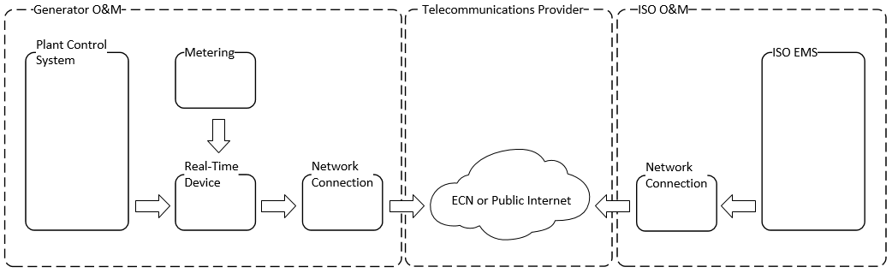

Coordination of Changes to the Real-Time Device
The intent of this section is to provide a process for notification and approval for installation of upgrades to the Real-Time Device as requested by a Participating Generator or required by the CAISO, based on the understanding that the overall functionality of the system must be ensured during upgrades without adversely affecting the CAISO’s EMS.
The Participating Generator must safeguard and protect the Real-Time Device (hardware or software or both) and must treat the Real-Time Device as its own confidential business property. The Participating Generator must ensure that no person having access to the Real-Time Device attempts to modify or reverse engineer the Real-Time Device software. The Participating Generator must also take reasonable steps to ensure that all persons having access to the Real-Time Device observe the Participating Generator’s obligations relating to the Real-Time Device.
The CAISO maintains a database that contains, for each Real-Time Device, the data points required from the Real-Time Point Definitions contained in this document. This Real-Time Device database may also contain additional data as required for mapping to the CAISO’s EMS. In order to maintain operation of the EMS, the CAISO requires prior notification and approval of all revisions to this Real-Time Device database.
A Participating Generator may make modifications to its Real-Time Device to support its operations, including the addition of data input/output points (which may or may not be made available to the CAISO) and the addition or replacement of hardware, as required to accomplish the Participating Generator’s purposes, provided that:
- The Participating Generator coordinates such changes with the CAISO and first obtains from an CAISO Energy Data Acquisition Specialist the relevant information from the latest revision of the CAISO database of Real-Time Devices.
- The Participating Generator remains solely responsible for all costs and other consequences associated with any interruption, as a result of such changes or modifications, in the ability of the Real-Time Device to communicate with the CAISO’s EMS, including financial consequences, according to the CAISO Tariff.
- The Participating Generator notifies the CAISO at least seven days prior to any revision.
- The Participating Generator submits a database revision for review by an CAISO Energy Data Acquisition Specialist and clearly states the proposed database changes, including the new revision, the installation date, and a valid OMS outage number.
- Following CAISO approval of the database revision request, the Participating Generator adheres to the requirements contained in this document during the installation of the changes.
- The Participating Generator notifies the CAISO before installation of the changes and participates with the CAISO in joint testing prior to placing the Real-Time Device back in service.
The CAISO requires prior notification and approval of all vendor software upgrades to the Real-Time Device in order to assure that the changes do not have an adverse impact on the CAISO’s EMS. The Participating Generator’s obligations are as follows:
- The Participating Generator must notify the CAISO at least seven days prior to any software upgrade installation.
- The Participating Generator must provide a valid OMS outage number that clearly covers the software upgrade. (For more information outage coordination, see CAISO documentation on Outage Coordination under References.)
- Upon the CAISO’s approval of the software upgrade installation request, and during installation of the upgrade, the Participating Generator must adhere to all requirements contained in this document and must follow all Outage Coordination process in accordance with the CAISO Tariff.
- The Participating Generator must notify an CAISO Energy Data Acquisition Specialist before installation of any software upgrade affecting a Real-Time Device.

Database Configuration and Management Affecting the CAISO’s EMS
The intent of this section is to provide a process for changes to a Real-Time Device database in the event of modifications, either by the CAISO or by the Participating Generator, that affect the functionality of the CAISO’s EMS software or database.
- In the event that the CAISO requires changes, the CAISO will notify each affected Participating Generator 120 days in advance of such changes and will provide a detailed explanation of the changes to be made.
- In the event that the Participating Generator requires changes to the Real-Time Device database that affect the CAISO’s EMS software or database, the Participating Generator must contact a CAISO Energy Data Acquisition Specialist 120 days in advance of the requested change.
  - In this case, the Participating Generator is responsible for making any necessary conforming changes to the Real-Time Device to maintain the interface with the CAISO’s EMS.
  - The CAISO will work with Participating Generators to stage the work so that no Generating Unit will be adversely affected in its ability to provide Regulation due to the unavailability of the human resources required to accomplish the changes.
- Any such modifications or changes must not compromise the Participating Generator’s right or ability to restrict access to information associated with the Participating Generator’s resources by any party.

Routine Testing and Maintenance of Real-Time Devices
The Participating Generator is solely responsible for the completeness and accuracy of all information transmitted by a resource to the Real-Time Device. The CAISO will not be responsible for the quality of the data transmitted through the Real-Time Device; the CAISO will only validate this information for accuracy. The CAISO and the Participating Generator must monitor the Participating Generator’s data transmitted through the Real-Time Device and, upon observation of any problems with that data, either party must provide the other party notice of the problem and both must work together to correct the problem.
The Participating Generator is responsible for all routine testing and maintenance of the real-time devices RIGs. The intent is to provide resource owners with the process to follow in order to maximize RIG operation while periodic maintenance and/or testing is performed. Minimizing the loss of real-time device RIG communication, and thereby minimizing the period when a resource is unavailable for bidding in the Ancillary Services markets, is in the best interest of both the resource owner and the CAISO. The resource owner must also avoid sending spurious or inaccurate data through the RIG real-time device as a result of testing and maintenance activities without first coordinating test plans and actions with the CAISO. Spurious and inaccurate data sent through a real-time device RIG to the CAISO and which the CAISO is not expecting to receive will impact the CAISO’s real time Balancing Authority Area load and reserve requirements calculations and its markets.
- Planned periodic maintenance and testing of the Real-Time Devices should be performed during scheduled resource outages.
- The Participating Generator understands that loss of Real-Time Device communication will result in the inability of the resource to participate in Ancillary Services markets.
- Outages must be requested through the resource’s Scheduling Coordinator. Planned work on Real-Time Devices should take place only between the hours of 8:00 am and 4:00 pm Pacific time, Monday through Friday, excluding CAISO holidays. (For more information, see CAISO documentation on Outage Coordination under References.)

Real-Time Device Implementation

Engineering and Deployment
The Participating Generator is responsible for all procurement, engineering services, and maintenance with regard to the installation of the Real-Time Device. The CAISO suggests that the first step in the installation process be that the resource coordinates a “kick off” meeting.

Real-Time Device Database Development
The CAISO’s Real-Time Device Engineer will provide technical assistance as required to the Participating Generator during the Real-Time Device hardware selection process. CAISO EDAS will also provide assistance during the development of the Real-Time Device database.

Telecommunication Circuit Installation and Power Requirements
The Participating Generator may obtain communication access circuit(s) from the ECN provider or an ISP provider. The LEC is responsible to provide the circuit to the plant main point of entry (MPOE) only. It is the Participating Generator’s responsibility to provide for, or contract services for, the implementation of high voltage protection (HVP) for these circuits where required. It is also the Participating Generator’s responsibility to provide on-site extension of the communication network circuit(s) to the actual Real-Time Device cabinet location on-site.
All service power to communication equipment and the Real-Time Device must be powered by an uninterruptable power supply (UPS) for the same amount of time the LEC is providing. This is not limited to Real-Time Device router, fiber optic power on both ends of the cabling, and Channel Service Unit/Data Service Unit (DSUCSU). Any communication equipment and device providing communications to the Real-Time Device must install a UPS or equivalent. For Eligible Intermittent Resources, see Power Reliability Requirements in this document.

Temporary Telemetry Exemptions
The CAISO may grant a temporary telemetry exemption for a resource that is new to participation in the CAISO’s markets or that currently exists in the CAISO’s markets, but an exemption is not guaranteed. The exemption is used for a Participating Resource that is unable to comply with applicable telemetry requirements prior to the transition of its resource to commercial operations in the CAISO’s markets, or for which telemetry is lost or not in good quality during participation in the CAISO’s markets. Temporary telemetry exemptions are focused on particular data. A Participating Resource must provide all required documentation in order to submit a request for a telemetry exemption.
8.4.1 – Pre-Commercial Units
Units that are working to complete the process to begin operating commercially in the CAISO’s markets, but have not completed all aspects of the project to provide required telemetry to the CAISO, may request a temporary exemption from the CAISO Tariff section 7.6.1(d). The temporary telemetry exemption form can be found on the CAISO website under Participate > Metering and Telemetry, and should be submitted to the CAISO as per the instructions on the form. The CAISO may accept, not accept, or alter the requested end date on the temporary telemetry exemption request as noted in the Telemetry Requirements Exemption Policy included as Attachment 1 to the form.

8.4.2 – Commercial Units
Upon notification from the ISO that either a telemetry failure has occurred or telemetry is in bad quality that impacts the following points, a resource owner is responsible for expeditiously investigating and resolving the issue to remain compliant with ISO Tariff section 7.6.1(d). Detailed information about telemetry points can be found in Section 14 of this BPM. The following points are to be considered critical:
- Generation Points – All resources
  - UPMW - Unit Point of Delivery MW
  - UGMW – Unit Gross MW*
  - UNMW – Unit Net MW*
  - UAMW – Unit Auxiliary MW*
  - UCON – Unit/Resource Connect
*If applicable for the resource
- Meteorological Points - Solar and Wind Resources
  - BPTMP - Back Panel Temperature
  - PAIRD – Irradiance
  - SPD - Wind Speed
  - DIR - Wind Direction
- Battery Specific Points
  - SOC – Instantaneous State of Charge in MWh
  - MXENERGY – Maximum Continuous Energy Limit in MWh
- Ancillary Service Specific Points – for units providing Regulation
  - UOHL - Unit Operating High Limit
  - UOLL - Unit Operating Lower Limit
  - UAGC - Unit Automatic Generation Control
- Co-Located,Hybrid, and VERs Providing AS
  - HSL – High Sustainability Limit
- Any future telemetry points that are direct inputs into the IFM/RTN Software, AGC, Load Calculation/Forecast

A telemetry failure is defined as having occurred when the data for any of the above points have been unavailable or in bad quality for 30-minutes, or when frequent yet shorter drops in data or quality have been noticed (intermittent issues). Upon notification to the resource owner and its Scheduling Coordinator of the telemetry issue, the Scheduling Coordinator will create a telemetry outage using the Outage Management System* (OMS) and will contact the resource owner to resolve the issue or request an exemption from the CAISO for providing the telemetry data by the following deadlines:
• (5) business days after notification of the telemetry issue for resources whose range of operation or Pmax is >= 45 MWs, whichever is more.
• (14) business days after notification of the telemetry issue for resources whose range of operation or Pmax is < 45 MWs, whichever is more.

* OMS cards are optional for Meterological Points
During the time that good quality telemetry data is not being automatically provided to CAISO through the RTU, telemetry value updates will be expected to be verbally provided to CAISO by the Scheduling Coordinator as follows:
- For resources with a total capacity or range < 25 MW, no reports of generation or charging/discharging are required, other than the status of resolution of the telemetry issue, unless specifically requested.
- For resources with a total capacity or range of 25 – 150 MW, report every 25 MW change of generation or charging/discharging and report plant status changes (online, offline, configuration change).
- For resources with a total capacity or range of > 150 MW, report every 50 MW change of generation or charging/discharging and report plant status changes (online, offline, configuration change).
- For NGR resource only with total range <= 50 MWs, report changes every 25 MWH in SOC and MXENERGY
- For NGR resource only with total range > 50 MWs, report changes every 50 MWH in SOC and MXENERGY
Please note that the updates are required only for the data point(s) that have a Telemetry issue.
If a resource is certified to provide Ancillary Services, the resource shall not bid into the Ancillary Service market or self-provide Ancillary Services until telemetry is restored. Any awards or self provision already in place at the time of the telemetry failure would be subject to buy-back and possibly other settlement consequences. The temporary telemetry exemption form can be found on the CAISO website under Participate > Metering and Telemetry and should be submitted to CAISO as per the instructions on the form. Information required to be provided to CAISO on the form includes a detailed description of the issue, the steps being taken to resolve it, and the expected date of resolution of the issue. The CAISO will review the submitted telemetry exemption request and respond back to the resource owner and its Scheduling Coordinator as follows:
- If a telemetry exemption request is not accepted by CAISO, it will notify the resource owner and its Scheduling Coordinator, and provide guidance regarding what aspect of the request was not acceptable to CAISO. A new telemetry exemption request addressing the unacceptable aspect of the previous submission must be submitted to CAISO within (5) business days of the deficiency notification from CAISO.
- If the telemetry exemption request is accepted by CAISO, it will notify the resource owner and its Scheduling Coordinator, and will expect the issue to be resolved no later than the time identified in the accepted telemetry exemption request.
- If the telemetry issue cannot be resolved by the date committed to in the accepted telemetry exemption request, another telemetry exemption request must be submitted prior to the expiration of any existing accepted telemetry exemption that explains the delay and provides a new date for resolution of the issue.
- For telemetry issues impacting grid reliability, resources may be ordered offline by the CAISO Operators at any time. Telemetry Exemption status has no bearing on this decision.
- If CAISO deems that issue is not being appropriately addressed in a timely manner and/or not providing timely updates for MW changes, the resource may be denied a current or future exemptions, and even be issued an Operating Instruction to come offline by the CAISO Operators.
Note: The CAISO may accept, not accept, or alter the requested end date on the telemetry exemption request as noted in the Telemetry Requirements Exemption Policy included as Attachment 1 to the form.
An initial telemetry exemption will typically be granted in good faith assuming a reasonable plan for resolution is included in the telemetry exemption request. Any subsequent exemption renewal requests should includetwo forms of additional documentation from the following list:

- Purchase order for parts needed for repairs
- Signed agreements for contractors hired to complete troubleshooting
- Service tickets with communication service providers
- Emails that show substantial progress on telemetry restoration
- Other documentation as approved by CAISO on a case by case basis

Any and all exemption requests extending beyond 30 days will require documentation supporting the extenuating circumstances preventing telemetry from being restored. Exemptions beyond 30 days will be granted on a case by case basis and are not guaranteed. Telemetry has a direct impact on CAISO Real-Time Operations and Grid Reliability. All efforts are needed to expedite resolution of the telemetry issues are expected by CAISO.

Failure to resolve the telemetry issue by the end of an accepted telemetry exemption period, or to submit a telemetry exemption request or telemetry data as per the guidelines documented in this BPM section will result in a Rules of Conduct violation as per ISO Tariff section 37.6, and penalties will be assessed accordingly to the Scheduling Coordinator of the resource.

Resolution of the telemetry issue will be considered complete when the telemetry data in question has been received in good quality for (72) consecutive hours. For the purposes of penalties assessed as per ISO Tariff section 37.6, the days associated with the (72) consecutive hours of good quality data will not be considered. The resolution of the issue will be deemed to have occurred at the beginning of the (72) hour period. If the resource owner fails to work diligently to resolve the telemetry issue, the ISO will provide formal notification to the resource owner and its Scheduling Coordinator that the resource is not compliant with the ISO Tariff section 7.6.1(d) and therefore in breach of their contract with the ISO. The ISO will then proceed as per the parameters outlined in their contract with the ISO to have the resource associated with the telemetry failure removed from the Schedule 1 of their contract with the ISO. Upon removal from the Schedule 1 of their contract with the ISO, the Scheduling Coordinator association for the resource will also be terminated.

FNM Database Process and Real-Time Installation
The FNM database process and Real-Time Device installation for real-time telemetry data section references the required steps for new and existing Real-Time Devices entering or maintaining the installation.

CAISO FNM Database Process
Section deprecated. See New Resource Implementation Timeline in References.

New Database Submission

Standards to Submit Real-Time Device Database for CAISO Database Build
Section deprecated. See New Resource Implementation Timeline in References.

Real-Time Database Submittal Timeline
Section deprecated. See New Resource Implementation Timeline in References.

Network Physical Circuit Protection to the Resource
- Copper installation at the de-marc,
  - High-Voltage Protection (HVP) may be required by the Local Exchange Carrier (LEC)
  - Longer lead time (up to 90 days)
- Fiber optic installation at the demarc
  - Shorter lead time (30 to 60 days)
  - No HVP required in most cases

Network Circuit Provisioning and Monitoring

AT&T ECN or ANIRA IPsec VPN
- For the ECN option, the Participating Generator provides a router from an approved list of routers and contacts with AT&T to provision a T1 circuit.
- Alternatively, for the ANIRA option, the Participating Generator provides a broadband connection (Ethernet or cellular IP) to establish an Internet Protocol Security (IPsec) connection to the ECN; there is no need for the Participating Generator to provide an ECN router or a T1 circuit.
- For either option, the Participating Generator maintains an CAISO-provisioned digital certificate to provide encryption over the ECN.
- AT&T optionally provides 24x7 router and circuit monitoring with same-day technician dispatch.
- The Participating Generator optionally contracts with a third-party integrator.

Self-Maintained Network and Circuit Monitoring
- With this option, Participating Generators would provide or contract their own network and circuit monitoring and would be responsible for resolving any problems with the network circuit.

Standards for Point-to-Point Testing with the CAISO
Before a Participating Generator submits a request to test its Real-Time Device installation, the Participating Generator must pretest all data points to a DNP3 master simulating the CAISO connection without security prior to the scheduled test date. This pretest is to assure quick testing with the CAISO.
The Participating Generator has the responsibility to validate and notify the CAISO that the DNP3 point-to-point pretesting is complete. Use the CAISO Energy Data Acquisition Specialist E-mail Address in References to submit the notification. Without this notice, the schedule test date may be canceled.
Methods of pretesting
- DNP3 master emulator
- DNP3 master test set
- Other DNP3 software capable of polling the Real-Time Device
Additional Real-Time Device configuration needed before final testing can be performed
- Device PKI certificates installed
- Review documentation provided by CAISO
Important: It is essential that the Participating Generator perform pretesting with the Plant Control System and Revenue Meter through to a DNP3 master simulation before testing with the CAISO. Manipulation of real-time data at the Real-Time Device is not an acceptable method of testing unless the Real-Time Device is the resource’s control system.
Testing of points
See the procedure for Acceptance Testing for Real-Time Devices under References for more information on the following. Each analog point must be tested to full, mid, and low scale. The CAISO may, at its discretion, optionally allow other values.
- The On and Off state for each digital point must be verified.
- Calculated points must be tested by changing inputs to the calculation.
- Set Points will be tested to full, mid, and low scale.
Revenue meter real-time point testing for a new real-time Installation
- An CAISO revenue meter used for any analog points must be tested by injecting voltage and current into the meter. Other types of transducers can be used in lieu of an CAISO revenue meter.
Revenue meter real-time point testing for an existing Real-Time Device installation
- In this case, the Participating Generator may use a synced resource or a meter test to verify the real-time values.
Point testing with the CAISO shall be undertaken as the last part of the testing and installation phase.
The Participating Generator has the responsibility to complete all pretesting before scheduling CAISO testing. If not, a delay or rescheduling of CAISO testing may be required.

Required Personnel for Point testing
- At the scheduled RIG real-time device testing date, the following personnel are needed for testing:
  - Resource personnel capable of exercising each real-time point required to be sent to the CAISO’s EMS from the resource control system through the RIGreal-time device.
  - Integrator responsible for the RIG real-time device installation.
  - Revenue meter personnel who can inject test values into the meter to verify real-time data going to the CAISO’s EMS through the real-time device. The CAISO may make an exception to this requirement for an operating resource if it does not include new generation.

- Testing from the RIG real-time device to the CAISO’s EMS alone is not considered sufficient for a CAISO point test (i.e., plant control system to RIG real-time device to CAISO’s EMS).
- The final CAISO test will be complete at the time the resource is in Trial Operations or is an existing resource and it is running and synced to the grid.

Real-Time Device Data Validation
- After the Real-Time Device has passed the point to point testing and the resource has synched to the CAISO grid a 72 hour data test is performed. During this test, CAISO shall test the following examples:
  - Un-interrupted communication connection to CAISO
  - Un-interrupted Real-Time Device connection to downstream devices such as Revenue meter, Met station and SCADA systems.
  - All Analog and Digital data in good quality
  - All logics working as expected.

Upgrade or Replacement of a Real-Time Device
- Standards of replacing, upgrading, or modifying an existing Real-Time Device:
  - The Participating Generator must submit an OMS Outage for some time during the period Monday-Friday between 8:00 a.m. and 4:00 pm only. The existing Real-Time Device must be returned to service after 4:00 pm daily.
  - The Participating Generator must provide 72 hours lead time for scheduled testing times.
  - A third-party engineering firm may not request the existing CAISO spreadsheet directly from the CAISO. The CAISO must receive an e-mail from the Participating Generator granting permission for the CAISO to provide the spreadsheet to the third party.
  - The CAISO will verify the request with the Participating Generator.
  - The CAISO will only give IP addresses to the Participating Generator, unless directed differently.
  - All other point testing discussed previously is required.
  - If the resource is operating, generally, calculated points (UCON) cannot be tested. These points will be verified when the resource shuts down.

Outage Management for Meter or Real-Time Device work
The CAISO Energy Data Acquisition Specialist group will not approve any work on a Real-Time Device or CAISO revenue meter without an approved outage and a fieldwork appointment on the EDAS calendar.
Plant personnel will need to call an CAISO Energy Data Acquisition Specialist at 916-608-5826 or have an EDAS member included in a conference call before work can begin.
- Before the plant personnel calls, they must verify that:
  - The outage has a valid outage number.
  - The outage number is for the actual times, work, and equipment being performed.
  - The outage number has been started and the OUT (Active) state.
- The call is made to CAISO Energy Data Acquisition Specialist, 916-608-5826 Plant/Generator personnel coordinates all work for:
  - Third Party Meter Engineers: They are to call the CAISO Energy Data Acquisition Specialist group at the number above before removing a meter out of service.
- Real-time Integrators: They are to call the CAISO Energy Data Acquisition Specialist group at the number above before starting work on a real-time. What CAISO Real-Time Device Engineering is not responsible for:
  - Submitting the outage.
  - Starting the outage.
  - Obtaining the outage number.
  - Calling all the parties responsible.
- Taking the resource to the OUT (active) state. CAISO Energy Data Acquisition Specialist Action with an outage.
  - Call the CAISO Real-Time Operator before work starts.
  - Call the CAISO’s service center (SMSC) about the pending work.
  - Manually Replace the resource’s current MW output for the FNM and EMS load calculation, and coordinate with the plant personnel to keep values current during the outage.

Digital Certificates
The Participating Generator must meet the following requirements to obtain an CAISO-provisioned SSL/TLS digital certificate to secure Real-Time Device communications. See References for CAISO Energy Data Acquisition Specialist e-mail address and phone number.
- Copy CAISO EDAS on all certificate requests or correspondence.
- If the request is for a new installation, obtain the Common Name value for the Real-Time Device from CAISO EDAS either by e-mail or phone.
- The CAISO will ask if the Participating Generator intends to work with a third party to request, install, or renew a digital certificate.
- There is a ten-day lead time to provision digital certificates.
- All certificate requests must include a completed request with an attached Certificate Signing Request (CSR); see Request Form for Digital Certificate for Real-Time Device in References for the request form.
- Indicate on the form whether the request is for a new installation.
- The Participating Generator must e-mail the completed certificate request using the e-mail addresses listed in References under E-mail Addresses for Submitting a Certificate Signing Request.
- The Participating Generator must obtain an approved outage for the installation of the new digital certificate.
- At least two weeks prior to the expiration of an existing digital certificate, the Participating Generator must inform CAISO EDAS of the outage scheduled to replace the certificate.
- CAISO Energy Data Acquisition Specialist is not responsible for the timing of the renewal request sent by the Participating Generator.
- The Participating Generator can install the digital certificate on the Real-Time Device during the scheduled outage.
- The CAISO will inform each Participating Generator of pending expiration of digital certificates at least two months prior to expiration. It is the responsibility of Participating Generators to remain aware of pending expiration of digital certificates and to watch for notices.

Wind and Solar FNM Documentation Required
The additional requirements are covered in the Tariff Appendix Q must be provided by the Participating Generator for wind and solar resources, including Hybrid resources with a VER component and VER Co-Located Resources

AGC Operational Requirements for Generating Units

Required DNP3 and Telemetry Data Points for AGC
To meet the minimum requirement of real-time visibility for Generating Units providing Automatic Generation Control (AGC) to the CAISO, each Real-Time Device must be capable of communicating the following types of values to/from the CAISO’s EMS:
- Analog input values to the CAISO
- Digital input values to the CAISO
- Analog output (Set Points) from the CAISO
To meet the minimum requirement of real-time visibility for Generating Units providing Automatic Generation Control (AGC) to the CAISO, each Real-Time Device must be capable of communicating the following telemetry data points to/from the CAISO’s EMS:
- Unit Control Switch (UCTL)
- Unit Authority Switch (UASW)
- Automatic generation control (UAGC)
- Automatic generation control Set Point
- Automatic generation control feedback
- Unit Operating High Limit (UOHL)
- Unit Operating Low Limit (UOLL)
For a detailed description of the minimum data point requirements for Generating Units providing AGC Regulation to the CAISO please refer to Section 6.1 Point Matrix.
The CAISO Operations and Engineering groups have approved the list of data point requirements described herein. They are the minimum data point standards that will allow the CAISO to manage effectively the reliability of the grid. At any time, the CAISO may require additional telemetry values to meet real-time operational requirements.

AGC Control (Bumpless Transfer)
For resources providing AGC, the Real-Time Device may have the option to set up a bumpless transfer method for AGC control, to track Set Point when resources are off AGC control. A calculated Set Point will be stored in the Real-Time Device, continually updating with the current Point of Delivery MW value of the resource or aggregate resource. When the resource transfers to AGC control, and starts accepting valid Set Points, the calculation will deactivate. The calculation should only reactivate when AGC control is disengaged.

Eligible Intermittent Resources (EIR)

Applicability
The Eligible Intermittent Resources Protocol (EIRP) in Appendix Q of the CAISO Tariff imposes various communication and forecasting equipment and forecasting data requirements on EIRs and Hybrid Resources with a VER component with PGAs as well as additional requirements on such EIRs electing certification as a Participating Intermittent Resource (PIR). Section A13 of Appendix A of the BPM for Market Operations contains additional requirements for EIRs and PIRs that do not pertain to direct telemetry.

Power Reliability Requirements
The wind and solar EIR or Hybrid Resource with a VER component owner must provide a backup power source for the Real-Time Device, meteorological station equipment, revenue meter, and essential communication equipment (not limited to the router, network switch, fiber optic transceiver, and 120V plug-in power supplies), the backup power source shall be sized accordingly to carry that equipment load. A backup power supply may include, but is not limited to, uninterruptable power source (UPS), battery bank with solar panel charger, or dedicated wind turbine charging a backup battery bank with inverter. Whichever backup power source is installed, it shall be sized and provide power until the primary power source is restored.

Basic Meteorological Data
The CAISO required meteorological data points for EIRs and Hybrid Resources with a VER component participating in CAISO markets as a VER is covered in the CAISO tariff appendix Q section 3.

Meteorological Wind Speed
The unit of measurement for wind speed will be in meters per seconds (m/s) with a precision of one m/s.

Meteorological Wind Direction
The unit of measurement for wind direction will be in angular degrees from true north with a precision of five degrees.

Meteorological Barometric Pressure
The unit of measurement for barometric pressure will be in Hecto Pascal with a precision of 60 Hecto Pascal.

Meteorological Ambient Temperature
The unit of measurement for ambient temperature will be in degrees Celsius with a precision of 1 degree Celsius.

Wind Generation

Meteorological Station Requirements
Each Participating Generator with a wind EIR or Hybrid Resource with a VER component must install and maintain equipment required by the CAISO to support accurate power generation forecasting and the communication of such forecast, meteorological, and other required data in accordance to CAISO New Resource Implementation process timeframe and the tariff appendix Q. The use of SODAR and/or LIDAR equipment may be an acceptable substitute for wind direction and velocity based on consultation and agreement with the forecast service provider and the CAISO.

Designated Turbines
Designated Turbines are required to improve forecast accuracy within a wind Generator Facility.
Definitions:
Designated Turbine - A turbine designated by the CAISO, in which nacelle wind speed and wind direction is required.
Wind Site Information Form and Topographical Map
A wind EIR or Hybrid Resource with a VER component must submit in accordance to the New Resource Implementation process time frame and CAISO Tariff Appendix Q, the topographical map and the Wind Site Information Spreadsheet (see References) that has all the locations and heights for each wind turbine within a wind Generator Facility with latitude and longitude and shall be in degrees/decimals using WGS84 geodetic datum only. Note: “See topographical map” is not an acceptable input on the Wind Site Information form.

Solar Generation

Meteorological Station Requirements
Each EIR or Hybrid Resource with a VER component Generator Facility shall provide meteorological station(s) in accordance to the CAISO tariff appendix Q.
Solar Generating Facilities that require direct normal irradiance (DNI) and global horizontal irradiance (GHI) measurements may provide alternate radiometry meteorological station data. For example, meteorological station one may report DNI where meteorological station 2 may report GHI. All other meteorological data reporting requirements shall remain the same.
Solar Generating Facilities’ meteorological stations shall cover 90% of the facility’s footprint for each Resource ID. Each meteorological station shall have a coverage radius of 7 miles.

Basic Solar Meteorological Data
Table 11-1 has been removed and Tariff Appendix Q Section 3.2.2 has the devices list, Units of measure, and Accuracy..

Participating Generator Irradiance Component Requirements
Table 11-2 has been removed and Tariff Appendix Q Section 3.2.2 has the technology component requirements,

Solar Technology Definitions
The technology definition are now covered in Tariff Appendix Q section 3 - TBD

Flat Plate Solar Photovoltaic
Photovoltaic power generation employs solar panels comprising a number of cells containing a photovoltaic material.
- Fixed horizontal / flat roof: The panels are mounted parallel to the sky and the roof top.
- Fixed angle: The panel is statically fixed to an angle that optimizes its exposure to the sun year around.
- Azimuth tracking: A panel is attached to a device that tracks the horizontal movement of the sun to optimize solar production.
- DNI: Direct Normal Irradiance (DNI) is a measure of the solar irradiation striking a surface held normal to line of sight to the sun.
- Solar zenith angle: Zenith angle is the angle from the zenith (point directly overhead) to the sun's position in the sky. The zenith angle is dependent upon latitude, solar declination angle, and time of day.

Flat Panel Solar Collector
A typical flat-plate collector is a metal box with a glass or plastic cover (called glazing) on top and a dark-colored absorber plate on the bottom. The sides and bottom of the collector are usually insulated to minimize heat loss. Sunlight passes through the glazing and strikes the absorber plate, which heats up, changing solar energy into heat energy. The heat is transferred to liquid passing through pipes attached to the absorber plate.

Low Concentration Solar Photovoltaic
Low concentration solar photovoltaic is a system that has a solar concentration of 2-100 magnification of the suns. This is normally performed with the use of mirror or other material or devices that concentrate the suns irradiance.

High Concentration Solar Photovoltaic
High concentration solar photovoltaic is a system that has a solar concentration of 300 magnification of the suns or greater. This is normally performed with the use of mirror or other material or devices that concentrate the suns irradiance.

Concentrated Solar Thermal
Concentrated solar thermal systems use lenses or mirrors and tracking systems to focus a large area of sunlight onto a small area. The concentrated light is then used as heat or as a heat source for a conventional power plant such as a steam turbine.

Heliostat Power
Heliostat power plants or power towers are a type of solar furnace using a tower to receive the focused sunlight. They use an array of flat, movable mirrors called heliostats to focus the sun's rays upon a collector tower.

Greenhouse Power Tower
The greenhouse power tower combines the chimney effect, the greenhouse effect, and wind turbines to produce power. Air is heated by sunshine and contained in a very large greenhouse-like structure around the base of a tall chimney, and the resulting convection causes air to rise up the updraft tower. This airflow drives turbines, which produce electricity.

Sterling Engine
Sterling engine use the expansion or hot gasses and contraction of cool gasses to produce mechanical work. The engine is designed so that the working gas is generally compressed in the colder portion of the engine and expanded in the hotter portion resulting in a net conversion of heat into work. The cooler part of the engine at times has compressors to cool the gases, and the hotter part, uses mirrors to concentrate the heat from the sun.

Solar Site Information Form and Topographical Map
A Participating Generator solar EIR or Hybrid Resource with a solar component must submit in accordance to the New Resource Implementation process time frame and CAISO Tariff Appendix Q, the topographical map and the Solar Site Information Spreadsheet (see References) for locations and heights for each wind turbine within a wind Generator Facility with latitude and longitude and shall be in degrees/decimals using WGS84 geodetic datum only.

Proxy Demand Resource (PDR)
Proxy Demand Resources shall follow the direct telemetry standards defined in this BPM. Check section: Refer to Section 6.2.2 for telemetry timing requirements.

PDR Point Requirements

Real Load MW
Each PDR shall be required to provide real-time load values. The load is the total real-time load or the power consumed by the resource; it can be a directly measured or calculated. Load data can be provided directly from a field device, such as a revenue meter, or indirectly by interfacing to a PDR EMS. It can also be derived by statistical sampling of a resource’s underlying load. This data point is used to help establish a baseline and calculate the load reduction of a resource when the resource is dispatched. A method for calculating load is not valid unless approved by the CAISO.

PDR Unit Connectivity Status (PDR UCON)
The PDR UCON can be manually set by an operator or programmed to change status based on an ADS Dispatch. The PDR UCON represents connection of the resource to the grid.

Bias Load MW
Bias load is a calculated value that stores the initial real load of a resource when the PDR unit connectivity status (UCON) is initially set to ON (HIGH). The bias load is used to establish a resource’s baseline load.

Pseudo Generation MW
PDR will be required to provide a pseudo generation point. The pseudo generation point calculates the real load, bias load, and the PDR UCON points. The pseudo generation point calculation can be performed within a control system, EMS, or Real-Time Device.
The pseudo generation point allows the CAISO to model the PDR resources like a participating generator.

Statuses and Pseudo Generation Flow
Table 12-1 shows the sequence of the ADS signal when it changes for a PDR. (The CAISO’s ADS dispatches to non-regulation resources.)
Table 12-1: Sequence of ADS Signal for PDR
1A | If ADS Dispatch Signal > 0 | 1B | If ADS Dispatch Signal = Zero
 | Read to Start status = 0 |  | Read to Start status = 1
 | Start status = 1 |  | Start status = 0
 | PDR UCON = 1 |  | PDR UCON = 0
 | Real Load = Feeder Actual MW |  | Bias Load = 0
 | Set Bias Load = Real Load |  | Pseudo Gen = 0
 | Pseudo Gen = Bias Load - Real Load |  | Goto 1B
2A | Loop checks the ADS dispatch every minute.  if ADS dispatch > 0 then next step else go to 1B
 | Reset Real Load = Feeder Actual MW
 | Perform Pseudo Gen = Bias Load - Real Load
 | Go to 2A

Exhibit 12-2 illustrates the flow of PDR status and Pseudo Generation MW.
Exhibit 12-2: Calculations for Pseudo Generation
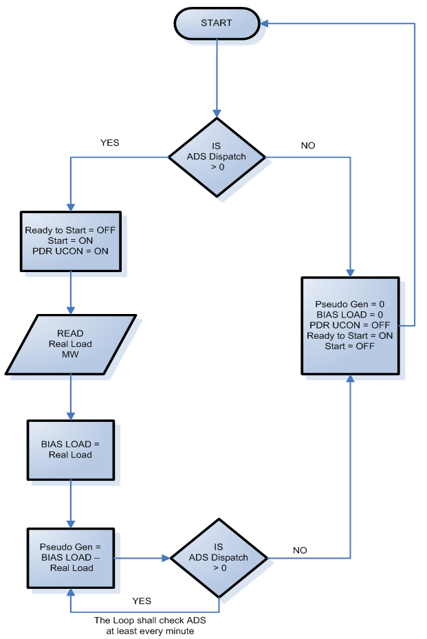

Timing and Configuration Requirements
Demand Response Provider (DRP) who have PDR resources greater than 10 MW or participate in the Ancillary Service market are responsible for adhering to all the current CAISO, DNP3 configuration, and security standards telemetry standards located on the CAISO’s Direct Telemetry Web page (see References).
PDR resources are not required to send updated load or generation values to the Real-Time Device every 4 seconds, PDR timing requirement has been extended per provisions set in section 6.2.2 of this BPM. However the Real-Time Device is still required to scan every 4 seconds.

Analog Data Requirements

Real Load (MW)
Definition
Each PDR resource will be required to provide the instantaneous load of each resource. The instantaneous load value is the compensated real-time megawatt load as seen at the CAISO grid. This value is either the actual or calculated value of the load where the resource connects to the CAISO-Controlled Grid. The value is compensated for losses typically arising from the difference between the measured point and the delivery point (such as transformer losses, and radial line losses). The value should align with the Point-of-Delivery (POD) megawatts calculated or measured by the CAISO revenue meters.
Purpose
The purpose of providing this data point is to validate that there is load at the resource. It is also essential in providing a baseline point that is used to calculate the pseudo generation point.
Methods of providing this value
Instantaneous Load data can be gathered from a revenue meter. The individual sites are aggregated up to the resource level. (It can also be gathered from a resources EMS system that tracks electricity consumption at each load point.) All methods for deriving instantaneous load must first be reviewed by CAISO engineers before being accepted as a credible load measurement.

Pseudo Generation (MW)
Definition:
Each PDR resource will be required to provide the pseudo generation of each resource. The pseudo generation will be calculated from the Instantaneous load MW and the PDR UCON points, this is a digital calculated point and is discussed in more detail in section titled “PDR Unit Connectivity Status (PDR UCON)
This pseudo generation calculation must be done in parallel with the PDR UCON calculation. This program contains two independent loops and is configured as follows:
- Validate that the current status of the PDR UCON is set to ON.
- If the PDR UCON is set to OFF, then the Pseudo Gen point will be set to 0 and the program will look back to START.
- If the PDR UCON is set to ON, then the BIAS LOAD point will hold the current value of the Instantaneous Load and keep that value until the program re-executes from START.
- Next, the Pseudo Gen will be calculated (Pseudo Gen = BIAS LOAD – Instantaneous Load)
- Each time the Pseudo Gen is calculated, the program must then validate the current status of the PDR UCON.
- If the PDR UCON is set to ON, then the Pseudo Gen will be calculated (Pseudo Gen = BIAS LOAD – Instantaneous Load) and the loop will continue.
- If the PDR UCON is set to OFF, then the Pseudo Gen point will be set to 0 and the program will look back to START.
For example, if the Instantaneous Load at a resource is 100 MW at the instant the PDR UCON is set to ON, then the BIAS point will store the 100 MW in its register. As the load drops to 95 MW, the pseudo generation will be BIAS – Instantaneous Load or 100 – 95 = 5 MW. When the PDR UCON is switched to the OFF status, the pseudo generation resets to 0 MW.
Exhibit 12-3: PDR UCON Status Flowchart
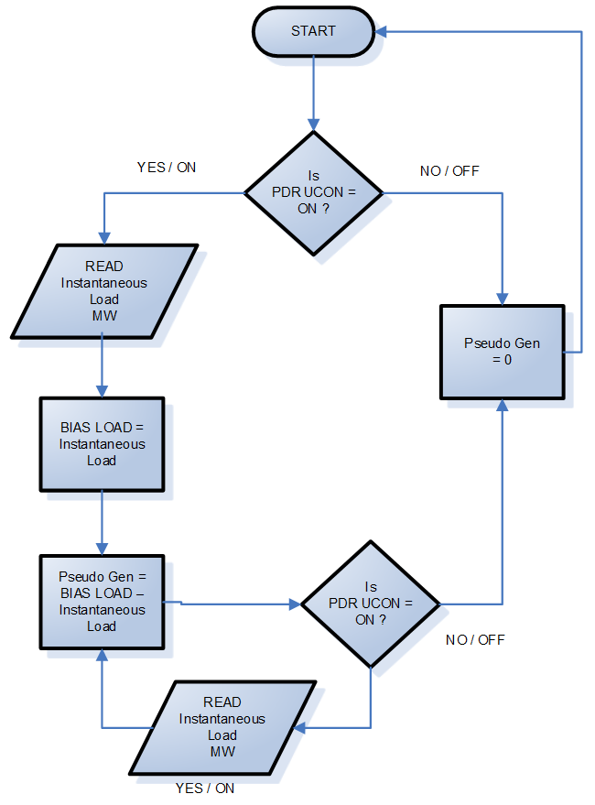
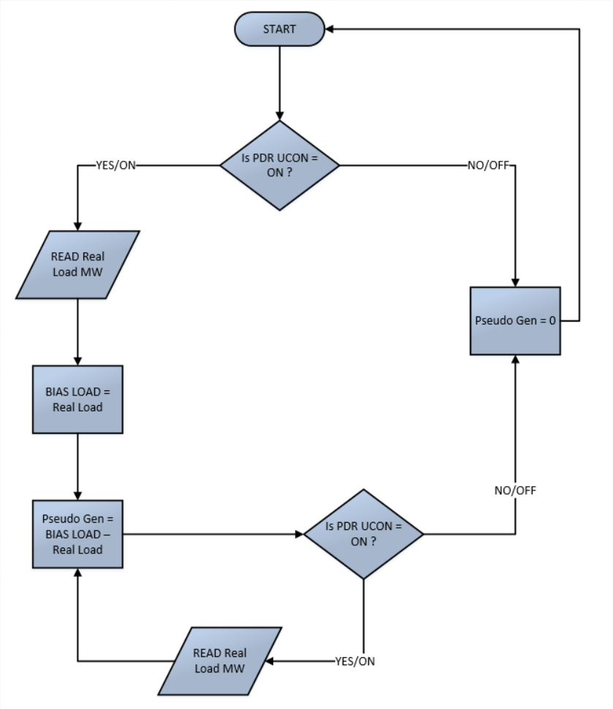

Purpose
It will allow CAISO to treat the PDR like an ordinary generator and allow the PDR to participate in Spin and Non Spin ancillary service markets.
Methods of providing this value
This calculation can be performed within a control system, SCADA, EMS, or within a certified Real-Time Device that has been re-certified for inclusion of this calculation.

Digital Data Requirements

Load Unit Connectivity Status (LOAD UCON)
Definition
The Load Unit Connectivity Status represents that the PDR has enough load to be dispatched. ON status means that the resource has load greater than 0 MW to be dispatched by the CAISO ADS as a pseudo generator. For example if a resource currently has a load of 10 MW, then the LOAD UCON bit will be set to ON. An OFF status means the PDR is at 0 MW of load. Exhibit 12-4 provides a program flowchart.
Exhibit 12-4: Load UCON Status Flowchart
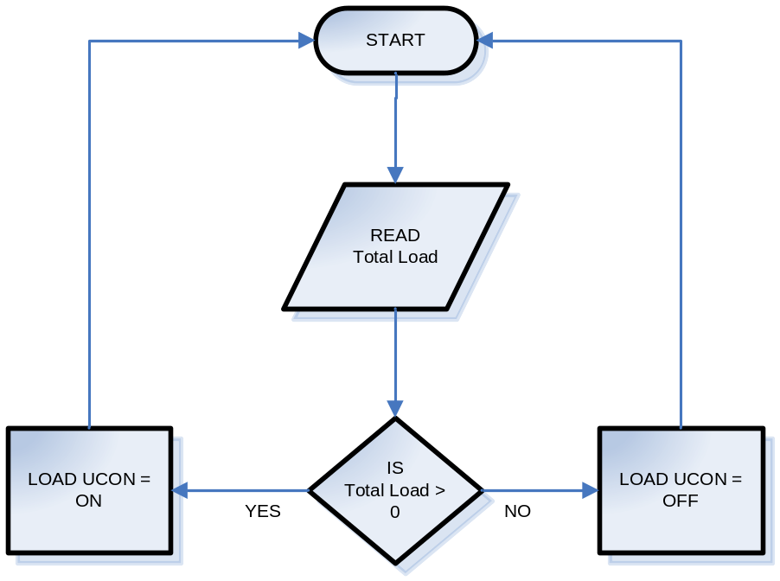
Purpose
The LOAD UCON value is used to determine if the load is available, as a pseudo generator, and can be counted towards Spinning or Non-Spinning Operating Reserve contribution. It provides a check and balance in the state estimator network topology and data quality work. The UCON also provides an indication if the pseudo generator is available for dispatch.
Methods of providing this value:
The UCON status can be programmed within a Real-Time Device, PLC, or a control system.

PDR Unit Connectivity Status (PDR UCON)
Definition
The PDR UCON in ON status is an indication that the PDR has been dispatched. CAISO dispatches for non-regulation resources are normally performed through the Automated Dispatch System (ADS). The PDR UCON can be manually set by an operator based off of an ADS signal. It can also be tied to an application programming interface (API) which automatically sends the ADS dispatch to the Real-Time Device to perform the calculation for the PDR UCON.
- If the LOAD UCON is set to ON and the resource receives an ADS dispatch greater than 0 MW, then the PDR UCON is set to ON.
- If the LOAD UCON is set to OFF and the resource receives an ADS dispatch greater than 0 MW, then the PDR UCON is set to OFF.
- If the LOAD UCON is set to OFF and the resource receives an ADS dispatch of 0 MW, then the PDR UCON is set to OFF.
- If the LOAD UCON is set to ON and the resource receives an ADS dispatch of 0 MW, then the PDR UCON is set to OFF.
- In all of these cases, the Program should loop back to Start and re-execute.
Exhibit 13-4 illustrates the flow of this program.
Exhibit 12-5: PDR UCON Status Flowchart
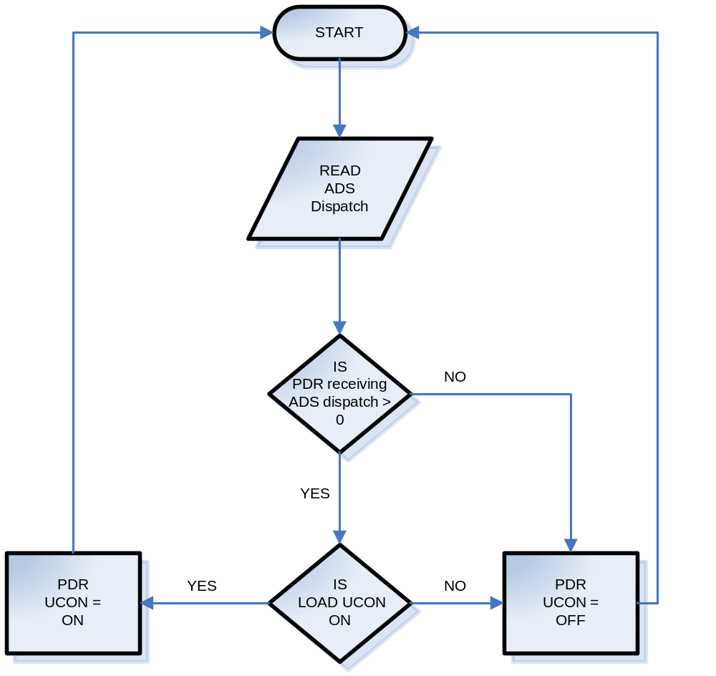
Purpose
The LOAD UCON value is used to determine if the load is available, as a pseudo generator, and can be counted towards Spinning or Non-Spinning Operating Reserve contribution. The PDR UCON value is used as a validity check when counting Operating Reserve contribution. The PDR UCON also provides an indication if the pseudo generator is currently being dispatched. It is also an important point in calculating the pseudo generation MW point.
Methods of providing this value
The UCON status can be programmed within a Real-Time Device, PLC, or a control system.

Real-Time Device Aggregator
Check sections: Refer to Section 5.7, 5.8 and 5.9 for other direct telemetry requirements.

Applicability
The Real-Time Device Aggregator standards in this Section 15 apply to Participating Generators who plan to use a single Real-Time Device to provide direct telemetry for multiple resources. To optimize the data gathering process, resources may use a Real-Time Device Aggregator to meet the CAISO’s telemetry requirements instead of installing a Real-Time Device for each facility. The Real-Time Device Aggregator must be a Participating Generator that can enter into agreements with other Participating Generators to provide direct telemetry through its Real-Time Device.

Real-Time Device Aggregator Responsibility
The Real-Time Device Aggregator is responsible for the real-time telemetry data aggregation and is the main contact for data quality issues, accuracy, and communication.
The Real-Time Device Aggregator will be responsible for coordinating required data points telemetered to the CAISO EMS.
In addition to meeting the requirements of Section 5.8 for its own resources, the Real-Time Device Aggregator has the obligation to maintain direct contact with the CAISO for all other resources that it is aggregating.

Real-Time Device Aggregator Authorization
The Real-Time Device Aggregator shall provide a letter on the Real-Time Device Aggregator’s letterhead setting forth a list of all resources that are being aggregated. The letter shall state that the Real-Time Device Aggregator accepts all responsibilities detailed in this BPM. The Real-Time Device Aggregator shall provide accompanying letters from each Participating Generator granting authorization to the Real-Time Device Aggregator to telemeter data on their behalf to the CAISO.

Real-Time Point Definitions
The Participating Generator is responsible for correctly providing all required points at the accuracy herein.

Analog Values

Unit Gross Megawatts (Gross MW)
Definition
This quantity is defined as the resource’s real power output, before subtracting the auxiliary real power load or step-up transformer real power losses.
Purpose
Gross MW is used to determine the Balancing Authority Area's generation pattern in the network model.
Methods of providing this value:
This value can be provided from instrument devices at the resource site (accurate transducers), at the Generating Unit terminals/low side of the step-up transformer, before any generation is intermingled with auxiliary load. It may be calculated from other measured points as agreed to by CAISO EDAS (i.e., Net MW plus Aux MW = Gross MW).

Unit Net Megawatts (Net MW)
Definition:
This quantity is defined as the resource’s real power output measured at the low side of the step up transformer after the auxiliary transformer if applicable. Or the quantity available after subtracting the unit auxiliary real power load, but before subtracting the unit step-up transformer real power losses.
Purpose:
Net MW is used to determine the CAISO Balancing Authority Area's generation pattern used in the network model.
Methods of providing this value:
This value can be provided from instrument devices at the resource site or it may be calculated from other measured points as agreed to by the CAISO RIG Engineer (i.e., Gross MW minus Aux MW = Net MW).
If Gross MW is equal to Net MW then Net MW is not required.

Unit Point of Delivery Megawatts (POD MW)
Definition:
This quantity is defined as the compensated, real-time value of the resource’s real power output at the point the resource connects to the electric grid to the CAISO Controlled Grid. It should align with the Point-of-delivery (POD) MW calculated or measured by the CAISO revenue meters. This value is either the actual or calculated value of the unit’s output at the point where the Generating Unit connects to the electric grid into the CAISO Controlled Grid. It must be a real time updated value and not averaged over time. This value is compensated for losses typically arising from the difference between the measured point and the delivery point (such as transformer losses, line losses, etc.). This value should include the Distribution compensation factor (DCF) if the resource has an executed WDAT agreement. For more information on DCF, refer to Metering BPM Attachment B, Section E.
Purpose:
POD MW is used to certify Ancillary Services and represents the Generating Unit’s real power delivery to the system. It is used to validate Ancillary Services Bids (scheduled versus actual) and to calculate accurate Operating Reserves. This point is also used as an input to the real-time network model used for system reliability monitoring.
Methods of providing this value
This value may be obtained by installing instrument devices at the POD. This value may also be calculated by providing an accurate conversion of existing Net MW values to point of delivery values within the existing control system or external system. The value must represent an accuracy of +/-2% of the true value of POD MW represented in the CAISO revenue meter.

Unit Auxiliary Load Megawatts (Aux MW)
Definition
Aux MW is defined as the real power load the Generating Unit provides to maintain its station service power. This point is required where a unit’s maximum auxiliary load is 1 MW or greater. Aux MW cannot represent other loads between the Generating Unit and the POD.
Purpose
The CAISO uses this value to determine the amount of replacement power required by each Generating Unit based on unit trips, and startups. This value is used to properly model the Generating Unit’s operating condition.
Methods of providing this value
Aux MW can be provided from instrument devices at the auxiliary transformer. It may be calculated from other measured points as agreed to by the CAISO Energy Data Acquisition Specialist (that is, Gross MW minus Net MW = Aux MW).

Gross Reactive Power or Gross Mega VAR (MVAR)
Definition
This quantity is defined as the unit’s reactive power output, before subtracting the unit auxiliary reactive power load or unit step-up transformer reactive power losses.
Purpose
Gross MVAR is used to determine the CAISO Balancing Authority Area's MVAR generation pattern in the network model.
Methods of providing this value
This value can be provided from instrument devices at the generating site (accurate transducers), at the Generating Unit terminals/low side of the step-up transformer, before any generation is intermingled with auxiliary MVAR. It may be calculated from other measured points as agreed to by the CAISO Energy Data Acquisition Specialist (that is, Net MVAR + Aux MVAR = Gross MVAR).

Point of Delivery Mega VAR (POD MVAR)
Definition
This quantity is defined as the compensated, real-time value of the reactive power (MVAR) at the point the Generating Unit connects to the CAISO-Controlled Grid. It should align with the Point-of-delivery (POD) MVAR calculated or measured by the CAISO revenue meters. This value is either the actual or calculated value of the unit’s output at the point where the Generating Unit connects into the CAISO-Controlled Grid. It must be a real-time updated value and not averaged over time. This value is compensated for losses typically arising from the difference between the measured point and the delivery point (such as transformer losses, and line losses).
Purpose
POD MVAR is used to establish a generating site’s reactive power delivery to the system and the impact of the generating site on system voltage. It is used to verify the generating site’s operation within CAISO Tariff requirements for reactive power, and is used as an input to real-time network model used for system reliability monitoring.
Methods of providing this value
This value may be obtained by installing instrument devices at the POD. This value may also be calculated by providing an accurate conversion of another data point measured at the same voltage level as the POD. The value must represent an accuracy of +/-2% of the true value of POD MVAR represented in the CAISO revenue meter.

Net Reactive Power (Net MVAR)
Definition
This quantity is defined as the unit’s reactive power output after subtracting the unit auxiliary reactive power load, but before subtracting the unit step-up transformer reactive power losses.
Purpose
Net MVAR is used to determine the CAISO Balancing Authority Area's generation pattern used in the network model.
Methods of providing this value
This value can be provided from instrument devices at the generating site or it may be calculated from other measured points as agreed to by the CAISO Real-Time Device Engineer (that is, Gross MVAR minus Aux MVAR = Net MVAR). If Gross MVAR is equal to Net MVAR then Net MVAR is not required.

Auxiliary Load Reactive Power (Aux MVAR)
Definition
Aux MVAR is defined as the reactive power load the Generating Unit provides to maintain station service power. This point is required where a unit’s maximum auxiliary load is one MW or greater. Aux MVAR cannot represent other loads between the Generating Unit and the POD.
Purpose
The CAISO uses this value to determine the amount of replacement MVAR required by each Generating Unit based on unit trips, and startups. This value is used to properly model the Generating Unit’s operating condition.
Methods of providing this value
Aux MVAR can be provided from instrument devices at the auxiliary transformer. It may be calculated from other measured points as agreed to by the CAISO Real-Time Device Engineer (that is, Gross MVAR minus Net MVAR = Aux MVAR).

Generating Unit Terminal Voltage (KV)
Definition
This quantity is defined as the terminal voltage of the Generating Unit, before the unit step-up transformer. It may be phase to phase or a calculated value of phase to ground multiplied by the square root of three. For a Net Scheduled QF subject to a QF PGA, this quantity is the voltage at the Point of Demarcation.
Purpose
The CAISO uses generator terminal voltage to determine each Generating Unit’s contribution to system voltage support. Terminal voltage is critical to proper network modeling. This value is useful in identifying voltage control issues, and MVAR circulation problems.
Methods of providing this value
This value can be provided from instrument devices at the Generating Unit terminals (accurate transducers), or, for a Net Scheduled subject to a NSPGA, at the Point of Demarcation.

Unit Operating High Limit (UOHL) [AGC Units Only]
Definition
The UOHL represents the maximum physical operating limit of the Generating Unit. The plant control room operator typically sets this limit to prevent the unit MW output from exceeding an upper plant operating limitation.
Purpose
The CAISO uses this value to set the maximum boundary for AGC calculations and unit availability at the POD.
Method of providing this value
The real-time UOHL value is typically provided directly from the device that the plant control room operator uses to manually set the operating limits.

Unit Operating Lower Limit (UOLL) [AGC Units Only]
Definition
The UOLL represents the minimum physical operating limit of the Generating Unit that participates in ACG. The plant control room operator typically sets this limit to prevent the unit MW output from exceeding a lower plant operating limitation.
Purpose
The CAISO uses this value to set the minimum boundary for AGC calculations and unit availability at the POD.
Method of providing this value
The real-time UOLL value is typically provided directly from the device that the plant control room operator uses to manually set the operating limits.

Governor Droop Setting
Definition
Droop is the amount of speed (or frequency) change that is necessary to cause the main prime mover control mechanism to move from fully closed to fully open. A governor tuned with speed droop will open its control valve a specified amount for a given frequency deviation. It is the change in steady state rotor speed, expressed in percent of rated speed, when power output is gradually reduced from rated to zero power. Applicable droop settings are set forth in CAISO tariff section 4.6.5.1 and in resources’ interconnection agreements.
Purpose
Primary Frequency Control is the first stage of overall frequency control and is the response of resources to arrest the locally measured or sensed changes in frequency. Telemetered Droop settings will assist the CAISO to compare and evaluate effective frequency response during disturbance, and to address techniques of measuring frequency response at the resource level.
Method of providing this value
Droop settings can be provided by the resource manufacturer or plant controller based on tested results. Direct telemetry will reflect any dynamic change in droop setting based on different constraints and types of resources. Data representation for 5% Droop should be 0.05.

Governor Dead band
Definition
The range of deviations of system frequency (+/-) that produces no turbine Governor response, and therefore, no frequency (speed) regulation. Dead band settings should not be exceed +/- 0.036 Hz ( 59.964 Hz to 60.036 Hz).
Purpose
Telemetered dead band will be used to measure response from resources during disturbances. This will also allow the CAISO to analyze the expected response and actual response to support interconnection reliability using the telemetered governor settings.
Method of providing this value
Direct telemetry from the plant controller. Data representation should be in Hz (Example: 0.036 Hz for for 36 millihertz)

Operating Ramp Rates
Definition
The rate, expressed in megawatts per minute, that a generator changes its output. The maximum ramp rate of a resource should be reflected in the Master File.
Purpose
Telemetered ramp rate will provide the CAISO with information needed to validate the actual response of the unit during grid disturbances.
Method of providing this value
Direct telemetry from plant DCS in MW/Min

High Sustainable Limit (HSL)
Definition
The instantaneous generating capability of a variable or intermittent Generating Unit (or component thereof), provided to the CAISO through telemetry at the Generating Unit. HSL can exceed the PMax of the resource and should reflect the true generation capability of the resource without any limitations.HSL must be provided for each VER component of the hybrid resource,VER co-located resource, or any VER that is providing AS. The HSL requirements are further defined by CAISO Tariff sections 4.18, 34.1.6.3, and Appendix A and Q.
Purpose
The HSL telemetry will be used primarily for forecasting. It will also be used to assist with renewable resources that are providing AS, including regulation, in addition to assessing the capability of a Hybrid Resource and for operational awareness.
Method of providing this value
HSL is a calculated value that comes directly from the site. When there is no supplemental dispatch or AS in place, the HSL is the generation capacity. When there is supplemental dispatch or another market instruction in place, the HSL is the generation capacity without the supplemental dispatch or AS signal. The generation capacity is calculated based upon known weather information and characteristics of the resource, such as: wind speed, wind direction and number of turbines for wind resources, and solar irradiance and available inverters from a solar resource. This information can be applied to a known power curve for the site to determine the sites generation capacity.

Following calculations can be used to determine HSL:

𝑊𝑖𝑛𝑑: 𝑆𝑖𝑡𝑒 𝑂𝑢𝑡𝑝𝑢𝑡∗ 𝑛𝑢𝑚𝑏𝑒𝑟 𝑜𝑓 𝑡𝑢𝑟𝑏𝑖𝑛𝑒𝑠 𝑎𝑣𝑎𝑖𝑙𝑎𝑏𝑙𝑒−𝑒𝑙𝑒𝑐𝑡𝑟𝑖𝑐𝑎𝑙 𝑙𝑜𝑠𝑠𝑒𝑠

𝑆𝑜𝑙𝑎𝑟: 𝑆𝑖𝑡𝑒 𝑂𝑢𝑡𝑝𝑢𝑡∗ 𝑛𝑢𝑚𝑏𝑒𝑟 𝑜𝑓 𝑖𝑛𝑣𝑒𝑟𝑡𝑒𝑟𝑠 𝑎𝑣𝑎𝑖𝑙𝑎𝑏𝑙𝑒−𝑒𝑙𝑒𝑐𝑡𝑟𝑖𝑐𝑎𝑙 𝑙𝑜𝑠𝑠𝑒𝑠
Where 𝑆𝑖𝑡𝑒 𝑂𝑢𝑡𝑝𝑢𝑡 refers to a solar site’s average irradiance or a wind site’s average wind speed.

The HSL must be greater than or equal to the actual VER component production. The HSL must propagate bad quality if the source irradiance or wind speed devices are in bad quality. If the VER has two or more weather stations, averaging or redundancy logic may be implemented. In this configuration, bad quality must be reported if all of the weather stationsare in bad quality.
. HSL can be set to update as frequently as the CAISO EMS polling rate of the RIG (every 1 or 4 seconds); however, Appendix Q of the CAISO Tariff specifies that the HSL shall update at a minimum every 12 seconds.

Digital Values

Unit Generator Breaker
Definition
The generator breaker is the breaker that closes when the unit is synchronized to the grid.
Purpose
The generator breaker positions are needed to determine the unit synchronization status.
Method of providing this value
The plant or resource control system can provide the status of the breaker.
The following three digital points are required for resources providing AGC.

Unit Connectivity Status (UCON)
Definition
The UCON status is an indication that a unit is synchronized to the grid.
Purpose
The UCON value is used as a validity check when counting Operating Reserve contribution. It provides a check and balance in the FNM and provides an indication of the number of Generating Units connected to the system.
Method of providing this value
This value is determined from the actual breaker status points of each Generating Unit and the pre-determined value of Gross MW, point of delivery MW, or the measurement of voltage is greater than a small percentage of Terminal Voltage and the High side breaker closed. If a line breaker exists then it should be included in the UCON calculation as well. Consult with the CAISO Energy Data Acquisition Specialist to determine the best solution.
Method of providing this value for Storage Devices
This value is determined from the actual breaker status points of each resource and the inverter ready status. UCON should be ON when the battery is both charging and discharging. Consult with the CAISO Energy Data Acquisition Specialist to determine the best solution.

Unit Control Status (UCTL)
Definition
The UCTL represents a software or hardware switch position that the resource is controlling remotely or locally. The On (High) indicates when the resource is available for remote supervisory control. The Off (Low) indicates the resource is controlled locally.
Purpose
The purpose of the UCTL is to validate whether the resource is providing remote control to supervised control operators.
Method of providing this value:
The resource operator selects the UCTL value through an operator interface display or physical toggle switches. Whichever method is used to select remote or local control, the indication will come from the resource control system.

CAISO Unit Authority Switch (UASW)
Definition
The Real-Time Device unit authority logic dictates which entity (the Generator, the CAISO, or other EMS system) has control over a Generating Unit at any given time. When sharing control of equipment, it is usually necessary to designate and report who has supervisory control of a specific Generating Unit at any given moment. This is done to prevent conflicting commands from being issued to the equipment. Unit authority switching is the means by which control of specific equipment is passed among the various control groups. Any logic or operator action that prevents or acts against the CAISO’s direct control will result in this status changing to Off (Low).
Purpose
When UASW is On (High) the resource will only be available for CAISO AGC Set Point and no other.
Method of providing this value
The UASW may be defined as a hardware or software switch. In either case, the switch must be available to the resource operator through the plant control system.

Unit Automatic Generation Control (UAGC)
Definition
The UAGC is the final indication that the resource is ready for the CAISO to send AGC Set Points. The AGC resource requires an AGC certification in order to participate in the CAISO Regulation market.
There is one UAGC digital point for each Resource ID.
Purpose
This point is used for Settlement purposes to determine that the intended resource met the scheduled generation expectation. When this point is ON (High), the CAISO EMS AGC control has authority to send MW Set Points to the Real-Time Device.
Method of providing the value
The UAGC status is a digital "AND" operand calculation of UCON, UCTL, and UASW points. The Set Point shall move the unit within the timing parameters outlined herein.

Automatic Voltage Regulator (AVR) / Power System Stabilizer (PSS) Status
Definition
The AVR is used to automatically control Generating Unit terminal voltage. The status must be represented as ON (in automatic control) or OFF (off-line).
The PSS is the system that works with the AVR to respond to frequency excursions. The status shall be represented as On (in service) or Off (out of service).
Purpose
AVR and PSS device status points are required to assess system reliability. The AVR and PSS status points are required from all Generating Units subject to WECC requirements. These points are also used in post-event analysis and for system stability simulations.
Method of providing this value
These values must represent the ON (high) status from the AVR and PSS devices and may not come from a calculation or user entered value. Data points for AVR and PSS status are not required for units that do not have these devices installed.

Governor Blocking status
Definition
Blocking the governor or governor-like control device of a resource essentially bypasses the governing feedback mechanisms and maintains the generator at a fixed output level. If the flag is set to ON then the resource is not expected to respond to frequency deviations.
Purpose
It is important to monitor resources that are capable of responding to frequency deviations. If telemetered governor status is set to ON due to physical operational constraints then the resource is not expected to respond to frequency deviations.
Method of providing this value
Plant load controller can provide telemetry to report if resources are capable and ready to respond to frequency deviations. Telemetry will have two states. ON = 1 and OFF = 0
The CAISO has developed the following implementation schedule for resources to implement the new telemetry requirements.
Resource MW size | Implementation date
>500MW | 6/15/2021
>400MW <=500MW | 7/31/2021
>300MW <= 400MW | 8/31/2021
>200MW <= 300MW | 10/30/2021
>100MW <=200MW | 1/30/2022
0.5MW <= 100MW | 5/31/2022

Switchyard Values
The Participating Generator may own some or all of the equipment associated with the connected switchyard. All switchyard values must meet telemetry timing requirements. If the Participating Generator owns switchyard breakers, it must provide, through the Real-Time Device, the status retransmitted.
The Participating Generator may own some or all of the equipment associated with the high voltage switchyard interconnecting the resource to the grid. The telemetry of all switchyard equipment (for example, circuit breakers, circuit switchers, motor operated disconnects, transformers, and transmission lines) directly associated with connecting the resource to the grid must be communicated through the Real-Time Device regardless of the interconnecting equipment’s ownership. If the switchyard directly connects to the CAISO-Controlled Grid and the Participating Generator owns the other switchyard equipment, the real-time telemetry of all switchyard equipment must be communicated through the Real-Time Device. Where existing telemetry to the CAISO is available for this switchyard equipment (that is, provided through the UDC), the CAISO will not require the telemetry of this other switchyard equipment to be provided through the Real-Time Device, provided the Participating Generator has arranged and can provide the CAISO with evidence of a formal agreement with the UDC to continue to deliver real-time switchyard telemetry values on behalf of the Participating Generator. However, the CAISO Energy Data Acquisition Specialist must agree with the specific methods used to provide the real-time telemetry.

Switchyard Line and Transformer MW and MVAR Values
Definition
The MW and MVAR quantities for the switchyard’s transmission lines and transformers.
Purpose
These values allow for proper network state estimation and assessment of network topology and assist in troubleshooting data quality problems (that is, sum of flows into and out of a bus). The MW and MVAR values are essential for modeling system restoration scenarios.
Method of providing this value
These values are obtained through devices connecting to the line CTs and PTs.

Switchyard Bus Voltage
Definition
This value is the voltage at the Generating Unit’s switchyard bus. It may be phase to phase or a calculated value of phase to ground multiplied by the square root of three.
Purpose
The switchyard bus voltage is used in determining network state estimation. It identifies voltage concerns and/or system-imposed limitations on reactive support.
Method of providing this value
This value is provided from bus PTs.

Switchyard Device Status
Definition
The breakers, circuit switchers, and/or motor operated disconnects (MOD) status for each Generating Unit, line, bus, and transformer breakers in the Generating Unit’s switchyard are required.
Purpose:
These values are used in determining network topology for state estimation. They are required for system restoration and outage information. In some arrangements, they may be the basis for forming the UCON status.
Method of providing this value
These values are direct measurements from switchyard devices and/or device auxiliary contacts.

Aggregated Units
In certain situations, the CAISO allows aggregation of Generating Units and the associated telemetry. This is typically done where Generating Units are operated in an interrelated manner (such as through use of a common watershed, and operation in combined cycle configuration). In these situations it is important to work with the CAISO Energy Data Acquisition Specialist to determine the required data points. The following provides a guideline to help determine the necessary and correct data points for Aggregated Units.

Aggregated Gross MW and MVAR
This is a calculation of the sum of the individual unit Gross MW and Gross MVAR values. When applicable, Gross MW and MVAR are still required for the individual Generating Units. Requirements will vary on a case-by-case basis.

Aggregated Net MW and MVAR
This is a calculation of the sum of the individual unit Net MW and Net MVAR values. When applicable, Net MW and MVAR are still required for the individual Generating Units. Requirements will vary on a case-by-case basis.

Aggregated Aux MW and MVAR
This is a calculation of the sum of the individual unit Aux MW and Aux MVAR values. When applicable, Aux MW and MVAR are still required for the individual Generating Units. Requirements will vary on a case-by-case basis.

Aggregated Point of Delivery MW
Aggregated Point of Delivery (POD) MW is a required point and is typically the value of the MW at the point of interconnection to the CAISO-Controlled Grid. In this case, individual Generating Unit POD MW and MVAR are not required.

Aggregated Point of Delivery MVAR
This point requirement has been removed from this BPM

Aggregated Unit Connectivity (UCON)
Aggregated UCON is calculated from the status of all individual Generating Unit UCONs. For example, Aggregated UCON = Unit 1 UCON OR Unit 2 UCON. Individual Generating Unit UCON is based on a determination that at least one of the individual units’ breakers is closed and that a minimum threshold of unit Terminal Voltage or Gross MW is exceeded. Coordinate with a CAISO Energy Data Acquisition Specialist for calculation.

Aggregated Peaking Unit Start and Ready to Start
This point requirement has been removed from this BPM

Wind and Solar Point Definitions
The EIR owner or Hybrid Resource with a VER component owner must provide the following applicable real-time data points for the technology used. Reference appendix Q section 3 of the CAISO tariff for the additional required real-time points for a VER resource.

Direct Irradiance (DIRD)
Direct Irradiance can be measured with a pyranometer or equivalent equipment which measures solar irradiance in watts per meter (W/m²). All equipment used to measure solar irradiance must have an accuracy of ± 25 W/m². Direct solar irradiance is a measure of the rate of solar energy arriving at the earth's surface from the sun's direct beam, on a plane perpendicular to the beam, and is usually measured by a sensor mounted on a solar tracker. The tracker ensures that the sun's beam is always directed into the instrument's field of view during the day.

Global Horizontal Irradiance (GHIRD/GHI)
Global Horizontal Irradiance can be measured with a pyranometer or equivalent equipment which measures solar irradiance in watts per meter (W/m²). All equipment used to measure solar irradiance must have an accuracy of ± 25 W/m². The GHIRD/GHI is the total solar radiation (direct, diffuse, and ground-reflected irradiance) hitting the horizontal surface of the earth. The sensor shall be mounted on a meteorological station, set at the global horizontal angle of the earth in reference to the sun solar radiation.

Global Irradiance / Plane of Array Irradiance (PAIRD)
Plane of array irradiance can be measured with a pyranometer or equivalent equipment which measures solar irradiance in watts per meter (W/m²). All equipment used to measure solar irradiance must have an accuracy of ± 25 W/m². The sensor shall be mounted on a meteorological station, facing the same angle and direction as all other solar photovoltaic panels at the site.

Diffused Irradiance
Diffuse irradiance refers to all the solar radiation coming from the sky and other reflected surfaces except for solar radiation coming directly from the sun and the circumsolar irradiance within approximately three degrees of the sun.
- Diffused Plane of Array Irradiance (DPOA): Diffused plan of array irradiance sensors follow the same accuracy and mounting requirements as the GPOA sensors but shall be designed to measure diffused irradiance.
- Global Diffused Irradiance (DIFGH): Global diffused irradiance sensors follow the same accuracy and mounting requirements as the GHI sensors but shall be designed to measure diffused irradiance.

Back Panel Temperature (BPTMP)
Back panel temperature is measured in degrees Celsius, with an accuracy of one degree. The temperature sensor should be mounted behind a solar photovoltaic panel.

VER Megawatts (VERMW)
Definition:
This quantity is defined as the compensated, real-time value of the resource’s real power VER output. It must be a real time updated value and not averaged over time. This value is compensated for losses typically arising from the difference between the measured point and the delivery point (such as transformer losses, line losses, etc.). In cases where a Hybrid Resource has a VER and storage component, the VERMW must reflect the total VER generation output regardless of where energy is being delivered. Simplified Examples:
1. VER = 100MW and POD = 100MW, VERMW should be 100MW.
2. VER = 100MW, BESS = -100MW, POD = 0MW, VERMW should still reflect 100MW.
Purpose:
VERMW is used for purposes of forecasting and reliability and represents the Generating Unit’s real power of the Resource’s VER component.
Methods of providing this value
This value may be obtained by installing instrument devices that measure only the VER part of a hybrid resource. The value must represent an accuracy of +/-2% of the true value of VER MW output.

Battery Point Definitions
All Battery resources must provide the following applicable real-time data points for the technology used. Section 6.1 provides a table of the required real-time points for each type of technology.

Instantaneous State Of Charge (SOC)
The Instantaneous SOC is the amount of energy in MWh that the battery, in real time, has available for CAISO participation at the time this value is conveyed through telemetry. This value should be between the Minimum Continuous Energy Limit and Maximum Continuous Energy Limit as registered in the Master File, adjusted by any applicable outage, derate, or rerate. The SOC will be maintained within energy limit constraints (minimum and maximum) defined in the CAISO Master File. Data should be updated every four seconds and should vary from zero to maximum energy limit.

Maximum Continuous Energy limit
The Maximum Continuous Energy Limit is the maximum energy in MWh that can be stored in the battery for CAISO participation at the time this value is conveyed through telemetry. This value should align with what is registered in the Master File, adjusted by any applicable outage, derate, or rerate. This value cannot be above the maximum energy limit defined in the CAISO Master File. The derate should be reflected, when applicable, in real time.

Battery Energy Storage System (BESS) MW
The Battery Energy Storage System MW is the MW value being imported or exported from the Battery component of a Hybrid Resource. BESS MW should reflect actual uncompensated MW consumed or produced by the BESS component.
14.5.4 The Minimum Continuous Energy Limit
The Minimum Continuous Energy Limit is the minimum energy in MWh that can be stored in the battery for CAISO participation at the time this value is conveyed through telemetry. This value should align with what is registered in the Master File, adjusted by any applicable outage, derate, or rerate. This value cannot be below the minimum energy limit defined in the CAISO Master File. The derate should be reflected, when applicable, in real time.
The derate should be reflected, when applicable, in real time.

